Ms. Viola Chapman
Superintendent of Schools Michael Coyle, Commanding Officer
Northeastern Conference of Seventh-day Adventists New York City Police Department


Linden SDA (BSMART) School

Safety Plan

Academic Year 2016 – 2017

Print Date: Thursday, March, 2017

Precinct: 105th

Address Information

Address: 137-01 228th Street

Laurelton, NY 11413

Primary Contact Information | Work | Fax

Custodian: Geoffrey Reid 516-554-7299
Caleb McMahon
Senior SSA:

BRT Leader: N/A

Borough Safety Director: N/A

Building Council

NAME | TITLE | TELEPHONE CONTACT
Dr. Laurene Usher | Principal | (718) 527-6868
J. Bacchus | Facilities & Building Management | (516) 285-1034
G. Reid | Assistant Facilities & Building Management | (516) 554-7299
Warner A. Richards | Pastor | (718) 527-1950
Parkinson Small Jr. | First Elder | (516) 529-2053
Pauline Brown | Daycare Director | (516) 708-6787
M. John | Daycare Board Chair | (718) 809-9956
Michael Spates | Maintenance Task Force | (516) 465-1226
Donovan A Lauther | School Board Chair | (917) 523-8466
 | Risk Management

1
This plan contains confidential information and should not be posted online, reproduced, or distributed, except in cases of emergency.

Contents

Section Topic

Section 1 School Safety Agents

School Safety Post Instructions

Official Radio Codes

School Safety Agent Post Assignment Form

Section 2 Building Information

For each building:

- General Building Information
- Accessibility
- Elevators
- Escalators
- Electromagnetic Locks
- Stairwells
- Vaults
- Pools
- Control Panel
- School Yard
- Intrusion Alarm
- CCTV/Video Surveillance

Section 3 Other Facilities Information

Transportable

Cafeteria

Section 4 Critical Security Notifications and Offices

Section 5 School/Program/Academy Information

For each school / program:
- Principal
- Operational Information
- Staff & Offices
- # Students per Grade
- School Personnel & Liaisons
- Chain of Command
- Class Schedules
- Lunch Schedule
- Yard Duty Assignments
- Hall Duty Assignments
- Dismissal Schedules and Information
- Additional School Activities/Community Based Organizations (CBOs)
- Pool Use

Section 6 Non-Instructional Offices & Organizations

Administrative Offices

2

This plan contains confidential information and should not be posted online, reproduced, or distributed, except in cases of emergency.

Section 7 Emergency Assignments, Egresses, and Relocation Sites

Building Response Team

Emergency Egresses

Relocation Sites

Floor Wardens

Shelter-In

Emergency Communications/Command Post

Section 8 Safety Evacuation Procedures for Special Needs Students/Staff

Evacuation Staging for Students and Staff with Special Needs – Guidelines Special Needs Coordinator
Special Needs Students

Program Schedules and Attendance Special Needs Staff Members
Summary of Staging Areas for Students / Staff with Special Needs Holding Rooms
Areas of Fire Rescue Areas of Rescue Assistance

Section 9 Medical Emergency Response Information

Health Protocols

AED Procedures

Location and Status
AED Contact Information

Health Resources: Personnel and Supplies

Section 10 Procedures and Assignments

Site Entry Information

Internal Communications

Visitor Control Procedures & Visitor Log

Emergency Situations and Procedures

- 911 Procedures
- Medical Emergencies
- General Response Protocols (GRP)
- GRP Summary of Student and Staff Response
- Shooting / Hostage Situation
- Bomb Threat
- Bomb Threat Checklist
- Building Collapse / Explosion
- Chemical Spill / Natural & Propane Gas Leak
□ Fire Emergency
- Fires Safety & Fire Drills
- Shelter-in
- Lockdown
- Command Post Checklist
- Missing Student Protocol/Door Alarm Response Protocols
- Reunification Guide/Reunification Protocols
- Closing Procedures

3

This plan contains confidential information and should not be posted online, reproduced, or distributed, except in cases of emergency.

Section 11 Supplemental Documents

Section 12 Committee Members & Meetings / School Safety Plan Endorsement Page

Section 1 School Safety Agents

It is the duty of the School Safety Agent Level III and other School Safety Agent(s) to work in conjunction with school administration to help maintain order and safety. A specific duty of the Agent Level III is to report any untoward incident to the School Safety Division Operations Center, (718) 730-8800. In the absence of the School Safety Agent Level III, the second-in-command (i.e., the assigned School Safety Agent) will assume this responsibility. In emergencies, the School Safety Agent Level III has the authority to alter assignments as the needs of the building change.

The Senior School Safety Agent(s) for this site is/are: Mr. Melvin

Other School Safety Agents listed for this plan are: Caleb McMahon

School Safety Post Instructions

Each School Safety Agent supervisor and School Safety Agent has specific functions to perform. These duties and responsibilities include:

- School Safety Agents will conduct themselves in a professional and courteous manner at all times.

- School Safety Agents will not allow students to remain on their post for extended conversations.

- School Safety Agents will remain on their assigned posts until relieved by authorized personnel, instructed by School Safety Agent supervisor and/or Administration, or to respond to an immediate security situation.

- All students/intruders picked up for infractions will be referred to the school administration (Principal, Dean, Counselor, Chairperson, etc.).

- School Safety Agents will report untoward incidents to the School Safety Agent supervisor and Administration.

- The School Safety Agent supervisor or Principal will call or radio in the appropriate report(s). In the absence of a School Safety Agent supervisor or school administrator, School Safety Agent will call or radio in the required report(s) in a timely manner.

- School Safety Agents will escort all intruders to the School Safety Agent supervisor and/or appropriate school administrator.

- School Safety Agents will call for backup/assistance when necessary.

4

This plan contains confidential information and should not be posted online, reproduced, or distributed, except in cases of emergency.

Official Radio Codes

When applicable, walkie-talkie radios will be used by the assigned School Safety Agents and the Principal and/or Designee. These radios will enable staff members to keep in constant communication and to notify each other in case an intruder is present or other serious conditions emerge. The "Official Radio Codes" should be used at all times.

10‐01 | Call your command
10‐02 | Report to your command
10‐03 | Call Dispatcher By (Central)
10‐04 | Acknowledgment (O.K.)
10‐05 | Repeat Message
10‐06 | Standby
10‐07 | Verify Address
10‐10 | Possible Crime
10‐11 | Alarm (specify type)
10‐13 | Assist Police Officer/Agent – Emergency
10‐20 | Past Robbery
10‐21 | Past Burglary
10‐22 | Past Larceny (specify: auto, from person/other)
10‐24 | Past Assault (specify)
10‐25 | Child Abuse in the Past
10‐29 | Other Crimes in the Past (specify)
10‐30 | Robbery in Progress
10‐31 | Burglary in Progress
10‐32 | Larceny in Progress (specify: auto, from person/other)
10‐33 | Explosive Device or Threat
 | NOTE: Portable radio should NOT be used when in the presence of a suspected bomb, explosive or
 | incendiary device.
10‐34 | Assault in Progress (specify)
10‐35 | Child Abuse in Progress
10‐39 | Other Crime in Progress (specify)
10‐50 | Disorderly Person/Group or Noise
10‐51 | Roving Band (specify direction of travel & number in group)
10‐52 | Dispute (Specify)
10‐53 | Vehicular Accident (Specify)
10‐54 | Ambulance Case (specify type)
10‐55 | Ambulance Case No R.M.P. required
10‐56 | Verify if Ambulance Needed
10‐58 | Fire Drill (Specify Location)
10‐59 | Alarm of Fire (Specify Type)
10‐61 | Precinct Assignment ‐ not available (give condition and/or location, e.g., mail run, at S.H., patrol with Pct.
 | C.O., etc.)
10‐62 | Out of Service ‐ Mechanical (give condition and location)
10‐63 | Out of Service (Meal)
10‐65 | Utility trouble (specify nature and if ESU responding or not)
10‐66 | Unusual Incident Examples: train derailment/collision, plane crash, building collapse.
10‐67 | Traffic/Parking Condition (specify)
10‐68 | See Complainant re: (specify)
10‐69 | Other Non‐Criminal Incident (specify)
10‐80 | Cancel (specify unneeded service)
10‐82 | Verification/Arrest (give number detained)
10‐83 | Report/notification at station house
 | 5

This plan contains confidential information and should not be posted online, reproduced, or distributed, except in cases of emergency.

10‐84 | Arrived at scene
10‐85 | Need Additional Unit (specify type & reason)
10‐86 | Female In/Female Out of Vehicle (indicate time)
10‐87 | Unit to hospital (specify hospital)
10‐89 | Other Interim Status (specify)
10‐90U | Unable to gain entrance
10‐90X | Unfounded
10‐90Y | Unnecessary
10‐90Z | Gone on arrival
10‐91 | Non‐crime corrected
10‐92 | Arrest
10‐92C | Crime Arrest (felony/misdemeanor), include number arrested in all cases.
10‐92F | Family Offense arrest made
10‐92J | Child Abuse arrest effected
10‐92Q | Other arrest (specify type)
10‐93C | COMPLAINT REPORT prepared a report a crime (felony or misdemeanor, including a Juvenile Report for a
 | Crime) is prepared.
10‐93Q | Other report prepared (no arrest) [P.A.R., etc.]
10‐94 | Handled by previous tour
10‐95 | Non‐crime referred by another agency
10‐96 | Summons served
10‐97H | Patient removed to hospital
10‐97R | Patient refused medical aide
10‐98 | Resume Patrol (not acceptable as a final disposition from last unit on scene)
10‐99 | Other final disposition (must include remarks)

Final Dispositions (90‐97, 99) are to be used only when a unit is completely finished with an assignment (including paperwork, forms and notifications) and is available for another assignment. Disposition code is to be selected and transmitted by the unit.

6

This plan contains confidential information and should not be posted online, reproduced, or distributed, except in cases of emergency.

_________________________________________ | Supervisor ___________________________ | Per | 10 | Time
_________________________________________ | Supervisor ___________________________ | Per | 09 | Time
_________________________________________ | Supervisor ___________________________ | Per | 08 | Time
_________________________________________ | Supervisor ___________________________ | Per | 07 | Time
_________________________________________ | Supervisor ___________________________ | Per | 06 | Time
_________________________________________ | Supervisor ___________________________ | Per | 05 | Time
Date: | SSA | Per04 |  | Time
 | CampusName___________________________________________________________________ | Per | 03 | Time
 |  | Per | 02 | Time
SSAPostAssignments |  | PerPer | 0001 | AgentName&RankTimeTime
Precinct:

7

This plan contains confidential information and should not be posted online, reproduced, or distributed, except in cases of emergency.

Section 2 Building Information

Main Building

Address

Address: 137-01 228th Street Laurelton NY 11413 | City/State/Zip:

Building Information

How many floors does the building have that are used for instructional or
Administrational purposes?

If this Schools should be prepared to host other schools in the event of an emergency requiring relocation. “Common Areas” can be used for these purposes. The capacity of the common areas identified in this building are shown below:

Cafeteria(s): 1

Auditorium(s): N/a

Gymnasium(s): 1

Other:

Where is the electrical control panel in the building? Hallway by main Office

Where is the gas/oil shutoff in the building?

Where is the water shutoff in the building?

Where is the fire box in the building?

Does this building have a Panic Button? No

Where is the Panic Button located? N/A

Does this building have a Classroom Call Switch? No

Where is the remote control panel for electromagnetic locks in the building? N/A
Does this building have a basement? Yes

Does this building have a sprinkler system in all classrooms and corridors? No

Does this building have a sub-basement? No

Where are the chemicals/controlled substances used in the science lab stored?

Who is responsible for laboratory safety, including storage and maintenance of chemicals and laboratory equipment?

Does this building have central air conditioning? No

Does this building have a ventilation system? No

If yes, what type of ventilation system is it? N/A

If yes, where are the shut-off controls located? N/A

8

This plan contains confidential information and should not be posted online, reproduced, or distributed, except in cases of emergency.

What is the storage location for hazardous materials that are often used by school custodians (e.g., bleaches; combustible cleaning materials)?*

*All hazardous materials must be kept in an appropriate area that is locked, isolated, and properly ventilated.

Accessibility

Does this building have students that require the use of a Fully/Partially accessible

Relocation Site? No

Elevators

Does this building have elevators? No

Description

Type

Is the elevator staffed?

Does the elevator have a phone?

Intercom / Phone

Escalators

Does this building have escalators? No

Description

Location

Electromagnetic Locks

Does this building have doors with electromagnetic locks?

Stairwells

Does this building have stairwells? Yes

Vaults*

Does this building have a walk-in vault? No

Location

Who has access to the vault combination?

*Many schools are equipped with large walk-in vaults that serve as secure, enclosed storage spaces for protection of assets from loss, theft, or damage by fire, water, or chemicals. Special care should taken to ensure that any vault in a school building is 1) kept under responsible supervision when it is open, and 2) inspected daily, particularly at closing time. Vaults should not be used as spaces to conduct work, and only those persons who are authorized to handle material that is maintained in the vault should be admitted. To prevent fires, lighters, matches and other incendiary devices should not be allowed in the vaults.

Pool Information

Does this building have a functional pool? No

Location

9

This plan contains confidential information and should not be posted online, reproduced, or distributed, except in cases of emergency.

Hours of Operation

Who supervises pool activities during regular school hours?* N/A

*A copy of a valid lifeguard and professional rescuer/resuscitator certification(s) must be kept on file at the school at all times.

Is there an approved and certified Pool Safety Plan on file with the Department of Health and Mental Hygiene for this pool?

What is the storage location for hazardous materials* that are used for pool maintenance?

*All hazardous materials must be kept in an appropriate area that is locked, isolated and properly ventilated.

Control Panel Information

Who should be consulted regarding the location of the control panel? N/A

School Yard Information

Do students use this building's yard? Yes

Intrusion Alarm System

Does this building have an Intrusion Alarm System? No

Is it in working order? N/A

Are the exit doors connected to the Intrusion Alarm System? N/A

Exit Door Alarm System

Does this building have an Exit Door Alarm System? Yes

How many doors are connected to the Alarm System?

How many Staff members have access to reset the Alarm System?

Do School Safety Agents have access to reset the Alarm System?

CCTV/Video Surveillance System

Does this building have a CCTV/Video Surveillance System? Yes

How many cameras are installed? 12

How many cameras are in good, working order? 12

How many video monitors are installed? 2

How many video monitors are in good, working order? 2

What kind of device is used to record video images? HCVR

What specific areas are under surveillance? Doors, hallways, auditorium, yard

10

This plan contains confidential information and should not be posted online, reproduced, or distributed, except in cases of emergency.

Who oversees daily operation of the surveillance system? | Principal & office staff

Section 3 Other Facilities Information

Additional Facilities

Transportables

Does this site have transportables or temporary structures? Yes

In the event of an evacuation, can the street be accessed directly or through the schoolyard when exiting the transportable? Yes

The following transportable(s) or temporary structure(s) exist on this site:

Structure Type modular

Room(s) 2

Primary Egress

Secondary Egress

Cafeterias

Does this site have cafeterias? Yes

The following cafeteria(s) are on this site:

Building | Cafeteria Type | Room

Main Building Student & Staff Auditorium

Main Building

11

This plan contains confidential information and should not be posted online, reproduced, or distributed, except in cases of emergency.

Section 4 Critical Security Notifications and Offices

Phone numbers for the local police precinct, local fire house, local hospitals, and other critical contact information should be posted in visible areas throughout the building, such as the principal’s office, secretary’s office, dean’s office, guidance counselor’s office, NYPD school safety agent post, etc. In the event of an emergency, first dial 911.

Contacts

Local Fire House | (718) 341-1551
Jamaica Hospital | (718) 206-6000

New York City Police Department

Commanding Officer – Michael Coyle

Precinct: 105th

City Police Department - Precinct Contact

City and State Agencies

New York State Central Register (to report suspected child abuse) | (800) 635-1522

311 Government and Information Services Hotline

311 School Designee

Notify NYC (https://a858-nycnotify.nyc.gov/notifynyc/Enrollment/)

School Safety Plan Technical Assistance

Critical Offices
Office | Building | Room No.
Main Office | Main
Medical Room | Main
Guidance Counselor | Main

12

This plan contains confidential information and should not be posted online, reproduced, or distributed, except in cases of emergency.
Section 5 School/Program/Academy Information

School Information -

Principal

Dr. Laurene Usher

Hours of Operation

How many floors of this building does this
school/program/academy use? 2

Does this school/program/academy operate as a Night
School? No

Is this a Young Adult Borough Center (YABC)? No

Staff

Teachers: 16

Paraprofessionals: 0

School Aides: 2

Supervisors / Administrators: 1

Secretaries: 2

Other: 1

Total: 22

# of Students Per Grade Served

LYFE Center N/A

Sixth Grade

Seventh Grade

Eighth Grade

Post Secondary

Total:

School Personnel and Liaisons

UFT Chapter Leader Caren Zayde Moncher

AP of Security/Administration or Dean N/A

P.A. President/Home & School Leader Darwin Munroe

Parent Coordinator Darwin Munroe

13

This plan contains confidential information and should not be posted online, reproduced, or distributed, except in cases of emergency.
Chain of Command

The Chain of Command is a listing of school personnel who, in sequence, are in charge of the school in the absence of the Principal/Site Administrator. Each designated staff member should be knowledgeable about the Safety Plan and be able to assume a leadership role when necessary. Chain of Command should include Assistant Principals, Deans, teachers, and/or other staff members, as appropriate.

Position |  | Name |  | Title |  | Home Phone

1 Ms. Gillian Joseph Vice Principal 718-216-5122

2 Mirlande Pierre Jr. HS Vice Principal 347-233-1417

3 Lydia Akobi Elementary Vice Principal 347-513-7739

Class Schedule (see attached)

Period | Start Time | End Time | Monday | Tuesday | Wednesday | Thursday | Friday | Daily
0
1
2
3
4
5
6
7
8
9
10

14

This plan contains confidential information and should not be posted online, reproduced, or distributed, except in cases of emergency.

Lunch Schedule

Does this school/program/academy have a lunch schedule? Yes

Do the students remain in school for lunch? Yes

Period Cafeteria

5. Main Building, Room: Auditorium
Staff Assigned: Mazie Hollingshead and Sharon Stoute
Supervisor: Sharon Stoute

6. Main Building, Room:
Staff Assigned:
Supervisor:

8 Main Building, Room:
Staff Assigned:
Supervisor:

Yard Duty Assignments

Are school personnel assigned to monitor the school yard? Yes

 | Period | From | To | Staff Assigned | Supervised By
 | 1-2 | 11:30 | 12:00 | Grades. 1-2 Teachers | David Estick
 | 3-5 | 12:00 | 12:30 | Grades 3-5 Teachers | David Estick
 | 6-8 | 12:30 | 1:00 | Grades 6-8 Teachers | David Estick

Hall Duty Assignments

Are school personnel assigned to monitor hallways?

 | Period | From | To | Floors | Staff Assigned | Supervised By
 | First | 7:00 | 9:00 | 2 | Clifford Melvin | Clifford Melvin
 | Last | 2:30-5:00 | 5:00 | 2 | Clifford Melvin | Clifford Melvin

15

This plan contains confidential information and should not be posted online, reproduced, or distributed, except in cases of emergency.

Dismissal Schedules and Information

Building | Start | Using OPT? Exit | Staff Assigned | Supervised By
Time

Main 3:00 PM N/A 137th Street S. Stoute/R. Gabbidon A. Gallimore

Students who are not picked up by a parent/guardian wait in the Auditorium or Library

where they are supervised by Ronica Gabbidon/Sharon Stoute

Students who are not picked up by a parent/guardian wait in the N/A

where they are supervised by N/A

Additional School Activities / Community-Based Organization Partnerships

Does this school/program/academy have any additional school activities? Yes

Does this school/program/academy have any community based organizations working in the building? Yes

After School Building Response Team (BRT) Members:

[Name and BRT ROLE]

 | Activity | M | Tue | Wed | Thu | Fri | Sat | Sun
 | STEAM Program | 3-6 | 3-6 | 3-6 | 3-6 | X | X | X

 | Supervisor | Claris James | Special Needs Students | No
 | Administrative |  | Relocation Site(s):
 | Office: |  |  | N/A
 | Scanning: |  | Medical Supplies are kept: | No

Pool Use

Does this school/program/academy use the on-site pool (where applicable)? N/A

16

This plan contains confidential information and should not be posted online, reproduced, or distributed, except in cases of emergency.

Section 6 | Non-Instructional Offices & Organizations
Administrative Offices
Does this school/program/academy contain any external administrative offices? |  |  |  |  |  |  |  |  |  |  | NO
Program Name |  |  | M | Tu | W | Th | F | Sa |  | Program Director
Northeastern Conference of SDA |  |  | 9-5 | 9-5 | 9-5 | 9-5 | 9-12 | NA | Viola Chapman
Days/hours of operation |  |  |  |  |  |  |  | See above
Phone |  |  |  |  |  |  |  | (718) 291-8006
Building/Room(s) |  |  |  |  |  |  |  | 1
Number of Staff |  |  |  |  |  |  |  | 4
Non-Adult Population |  |  |  |  |  |  |  | NA

Early Childhood Services

Does this school/program/academy contain other services for children under 5 years of age? No

Program Name (e.g. Early

Head Start)

Service Contact

Phone

Building/Room(s)

Number of Staff

Service Enrollment

Early Childhood Dismissal Schedules and Information

Building | Start | End | Exit
 | Time | Time
Main Building
Students are picked up by a parent/guardian and are assigned to wait in the |  |  |  | N/A
where they are supervised by

17

This plan contains confidential information and should not be posted online, reproduced, or distributed, except in cases of emergency.

Section 7 Emergency Assignments, Egresses & Relocation Sites

Emergency Egresses

Every room occupied by students and/or staff, including those used intermittently throughout the day, must have a primary and alternate route to exit the room and, ultimately, the building.

When school principals and/or appropriate external authorities have made the decision to evacuate a school building, students, staff, and visitors to the building must exit using the designated egress and/or alternate egress route.

Please note: exits and streets are both required in this section. Cafeteria / Lunchroom, Auditorium, and Gymnasium, where appropriate, should be included in the list of rooms and exits.

Main Building

Room | Exits | Stairwells | Street Address
Auditorium | Front & Rear | N/A | 137st Ave & 228th Streets
Gym | Front & Rear |  | 137th Street
Main Office | Front & Rear |  | 137th Ave & 228th Streets
Grade 1 | Front & Chapel side |  | 137th Ave
Grade 2 | Front |  | 137th Ave & 228th Streets
Grade 3 | Front |  | 228th Street
Grade 4 | Front |  | 228th Street
Grade 5 | Front |  | 137th Ave & 228th Street
Grade 6 | Front & Rear |  | 228th Street
Grade 7 | Front & Rear |  | 137th Ave & 228th Street
Grade 8 | Front & Rear |  | 137th Ave & 228th Streets
Computer Lab | Front & Chapel side |  | 137th Ave
Music Room | Front |  | 137th Ave
Teachers’ Room | Front & Rear |  | 137th Ave
Library | Front |  | 228th Street
Nurse’s Station | Front |  | 137th Street

18

This plan contains confidential information and should not be posted online, reproduced, or distributed, except in cases of emergency.
Relocation Sites

Short‐term Relocation Sites should provide shelter to students and staff and allow for easy communication with Borough Safety Directors and other external supports. Short‐term Relocation Sites should be able to serve the instructional and educational needs of the relocating school for approximately one week.

The principal or designee as identified in the safety plan “chain of command” is responsible for all students and staff at the relocation site. The principal or designee as identified in the safety plan “chain of command” is responsible for all students and staff at the relocation site.

The primary and secondary relocation sites should be in close proximity to the main school site. In an emergency that affects the school’s entire neighborhood or a larger area, the primary and secondary location may be rendered unusable. In such cases, the third, “out of area” location should be used.

In situations where relocations may extend past one week (known as long term relocation) the DOE will determine an appropriate relocation site that may not be listed in the safety plan to accommodate the needs of multiple schools. As a result, this may also occur when an emergency requires the simultaneous relocation of multiple schools that have identified the same relocation site. Principals will be informed of the long‐term relocation site through Central and Field Support Center communications.

19

This plan contains confidential information and should not be posted online, reproduced, or distributed, except in cases of emergency.

Campus / Building Name

 |  | Relocation Site | Designee at Relocation | Capacity | Accessibility | Grades | # of
 |  |  | Site |  |  |  | People
 | Primary | Math House | Thea Stapleton | 70 |  | 1-8 | 70
 | Secondary |  |  |  |  | 1-8 | 200
 |  | Public School 156 |  | 200
 | Out of Area | Queens Public Library |  | 300 |  | 1-8 | 300

Floor Wardens

Each floor of a school building must be assigned a designated Floor Warden and, where staff are available, a Searcher. Those persons who are designated as Wardens and Searchers should be familiar with the Safety Plan, the location of exits and the location of the fire alarm system.

In an emergency, Wardens and Searchers are responsible for ensuring that all occupants are notified of the emergency, and that students and staff follow evacuation procedures safely. Wardens and Searchers should search lavatories and classrooms to ensure that all students, staff, and visitors are out of the building.

To ensure principal awareness of which floor wardens and other designees are present in the event of an emergency, schools may wish to require sign-in in a logbook at the beginning of each workday. Schools may also wish to provide floor wardens with armbands, baseball caps, vests, or another item to ensure their easy identification during an emergency.

20

This plan contains confidential information and should not be posted online, reproduced, or distributed, except in cases of emergency.

Floor Warden Name | Searcher | Floor/Post/Area
Egan Kingston | Egan Kingston | 1st Floor
Amy Gallimore | Amy Gallimore | 2nd Floor
Ronica Gabbidon | Ronica Gabbidon | 3rd Floor

Shelter-In

Designate school staff members who will be responsible for reporting to specific building exit doors during a Shelter-In.

During a Shelter-In all exit doors including kitchen doors and loading docks must be secured to prevent entry/egress during a Shelter-In emergency.

Principals should not be assigned to exit doors. While School Safety Agents (SSAs) can be assigned, consult with the SSA Level III prior to assigning SSAs to exit doors.

Staff Assigned | Title | Exit
Tony Cadrot | Music Teacher | 228th Street
David Estick | PE Teacher | 137th Ave
Egan Kingston | Bible/Math Teacher | Chapel

21

This plan contains confidential information and should not be posted online, reproduced, or distributed, except in cases of emergency.

Emergency Communications/Command Post

For emergency situations where the Building Response Team (BRT) activated is a command post must be established. This includes times when a building/school may need to Lockdown, Shelter-in, or Evacuate. The command center is the single location where all principals will report to gather and disseminate information to the members of the Building Response Team. The BRT Leader will obtain updates from activated BRT members and provide information to all principals so that a single decision can be made to ensure the safety of all staff and students.

All buildings will identify a Primary (internal) location as well as an Alternate (internal) location to be used as a command center. These locations should have specific equipment and materials readily available. This includes; floor plans; bullhorns; radios; batteries and chargers; and working telephones.

In cases where an evacuation is necessary the command center will need to be established outside the perimeter of the school site, in close proximity to the building at a location that will not interfere with first responders performing emergency operations. The external command center should be located in a location that can allow for schools to communicate with first responders.

Reminder: During Bomb Treats or incidents of suspicious packages, electronic communications (Cell phones, 2-way radios) is prohibited until authorized by first responders.

The Command Center locations are identified below.

Command Post | Room Number | Description
Primary | Main Office | Main Office
Alternate | Teachers’ Room | Teachers’ Room
External Command Post Location | Math House | Math House

22

This plan contains confidential information and should not be posted online, reproduced, or distributed, except in cases of emergency.

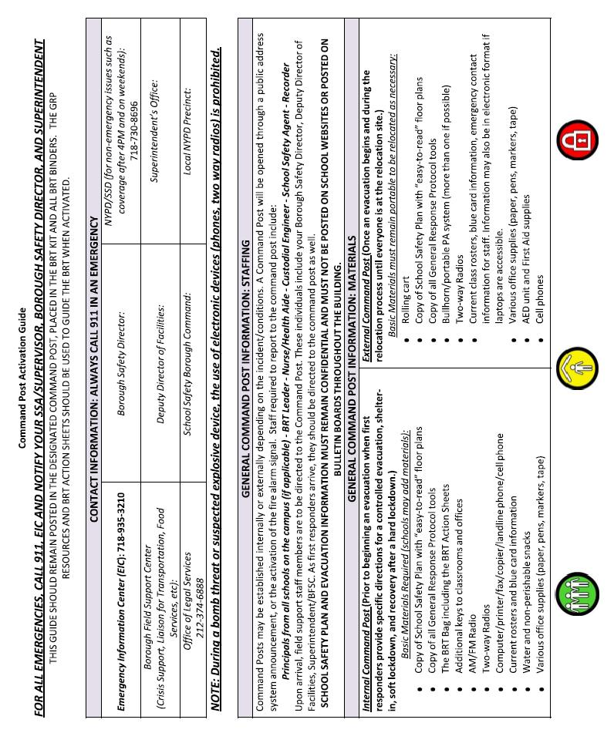

23

This plan contains confidential information and should not be posted online, reproduced, or distributed, except in cases of emergency.

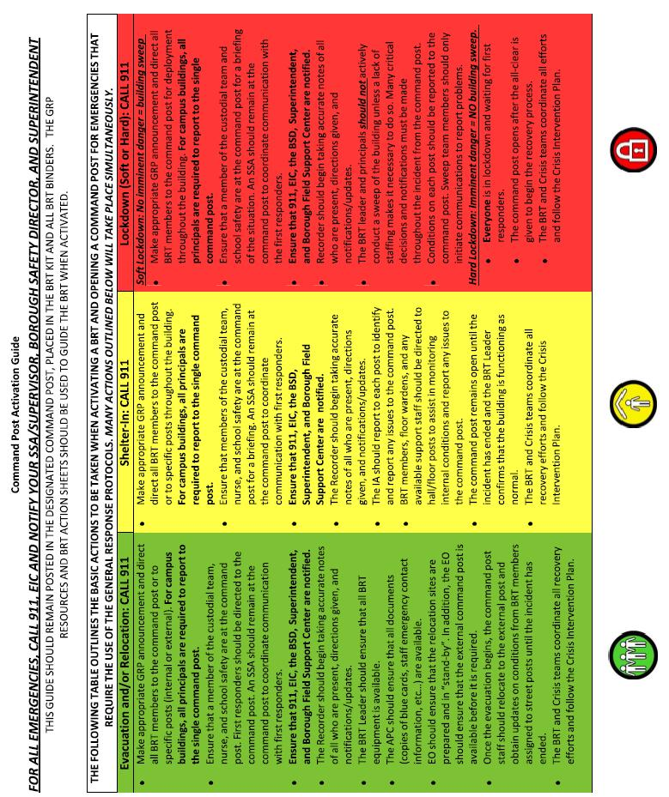

24

This plan contains confidential information and should not be posted online, reproduced, or distributed, except in cases of emergency.

Section 8 Safety Evacuation Procedures for Students/Staff with Special Needs

Regardless of whether students with limited mobility or other special needs are currently enrolled and/or staff members with limited mobility or other special needs are currently employed at any given site, all buildings must complete a current plan for safety evacuation procedures for these populations. (Students or staff with limited mobility can be assigned to a school at any time, regardless of whether the building is officially accessible.) In developing building-specific procedures, the school and church boards are encouraged to consult with their respective New York City Fire Department battalions and with the NYPD/School Safety Division.

Schools that do not have students/staff with limited mobility or other special needs currently on site are not required to complete individual-specific aspects of the Safety Plan, but must still complete the general evacuation procedures for students/staff with limited mobility, i.e., the location where program and schedule information will be posted, the indoor areas on each floor (by type), or the outdoor areas to which limited mobility students will be evacuated in the event of an emergency.

In an emergency, each student with limited mobility will require evacuation to one of the following:

- an area outside the building that is consistent with the evacuation procedures for the general school population; or,

- a designated area inside the building that can be considered:

  - an FDNY-approved holding room;

  - a fire rescue area (for sprinkler-equipped buildings only); or,

  - an area of rescue assistance; or

  - Any other appropriate space close to a stairwell or point of egress (to be determined in consultation with

FDNY and the NYPD School Safety Division).

Please note: The Principal must notify the parents/guardians of all limited mobility students named in this section of the evacuation procedures developed for their children.

Safety Evacuation Procedures Students with Limited Mobility must include:

- the name of the staff member with overall responsibility for ensuring that all limited mobility students are evacuated and accounted for, and that contact is made with responders;

- a list of students with limited mobility currently enrolled in the school;

- a program schedule specifying where limited mobility students are located throughout the day;

- attendance procedures so that each limited mobility student in attendance can be accounted for during an emergency;

- the names of individual staff members (and back-up staff members) responsible for safe evacuation of all limited-mobility students to designated areas inside the building, or safe area outside of the building; and,

- the designation / location of such rooms or areas, including egress routes from the building and predetermined evacuation areas outside of the building, where applicable.

Note: Limited mobility students generally require 1:1 assistance. There may be times, however, when assistance and/or supervision can be provided on a ratio other than 1:1 without compromising the safety and/or welfare of the student, as in the evacuation of a self-contained class of sensory impaired students, or the evacuation of a student whose IEP does not mandate a 1:1 paraprofessional and whose ability to ambulate is not increased by direct assistance. Such exceptions are generally dependent on the nature of the student’s disability and where the child is being evacuated to, and are subject to the school’s determination and the Safety Director’s approval that all procedures provide for the safety and welfare of the student. In any instance where the ratio of assistance and/or supervision for limited mobility evacuation is less than 1:1, the safety of that evacuation plan must be approved and signed off by the Safety Director.

25

This plan contains confidential information and should not be posted online, reproduced, or distributed, except in cases of emergency.

Section 9 Medical Emergency Response Information

Health Protocols

Some health conditions may affect a student’s participation in school activities, or may affect other students or staff. Schools receive information about student health conditions in a variety of ways. The one person in your school who is responsible for receiving all student health information is:

Name | Title | Agency
 | Nurse

Health information should be reviewed by a nurse, administrative staff, or other trained staff, in consultation with medical professionals. The person at your school (may be same as above) who is responsible for reviewing information about health conditions and consulting with medical professionals, as appropriate, is:

Name | Title | Agency
 | Nurse

The person (may be same as above) responsible for implementing health recommendations (e.g. activity restrictions, public health investigations, informational letters to parents, etc.) is:

Name | Title | Agency
 | Nurse

AED (Automated External Defibrillator) Procedures

According to New York State Education Law Section 917, all public schools must provide and maintain AED equipment at strategic locations to ensure access for use during medical emergencies. Whenever public school facilities are used for school-sponsored or school-approved curricular or extracurricular events or activities and whenever a school-sponsored athletic contest is held at any location, school officials and administrators must ensure the presence of at least one AED/CPR certified staff volunteer. Where a school-sponsored competitive athletic event is held at a site other than a public school facility, school officials shall assure that AED equipment is provided on-site.

Public school facilities are deemed “public access defibrillation (PAD) sites” and are subject to the requirements and limitations of this definition. Schools are required to post a list of the locations of each AED unit at their main entrance. Ensure your AED location poster is posted at the school’s main entrance and is easily visible. Although, we are not a public school, we would like to be proactive in creating and maintaining a safe learning environment for students, visitors and staff so that we can provide assistance during medical emergencies.

AED Locations and Status

Serial Number | Building | Location | Status
B13F-02497 | Main | Main Office | Operable

- Training

a. Trained personnel should have work schedules that ensure constant coverage when school building is open. Any staff volunteer may receive training, but administrators, custodians, secretarial staff, and other staff who are not assigned to classrooms are highly recommended.

26

This plan contains confidential information and should not be posted online, reproduced, or distributed, except in cases of emergency.

- Each school should ensure that at least six school personnel are trained where staffing permits.

- All coaches of intramural sports must maintain the required AED/CPR certification at all times.

- Training is voluntary and is provided free of charge to all staff, and may be arranged through the school. CPR/AED certification is valid for two years.

- Training certification must include successful performance of use of the AED, CPR for adults, children, and infants, and choking procedures for adults, children, and infants. Training provided by ESI is the best way to ensure staff has received appropriate training.

Trained | School | Building | Status | AED | CPR
Responders
Dr. Usher |  |  | Certified | Active | Active
G. Josephs |  |  | Certified | Active | Active

- Contact Person

  - Each principal must designate an AED contact person to coordinate all AED activities at the school.

  - The AED contact must have a work email address that he or she checks daily and responds to. Do not designate a person without access to a computer at work, or with a personal email address (e.g. AOL, hotmail, or yahoo).

Designated AED Contact Person | E-mail | Phone
Dr. Laurene Usher | Usher7@verizon.net | 516-606-4659

- Equipment Placement & Maintenance

  - Every school must have an unlocked wall cabinet containing a functional AED mounted at the main Office of the school where it is clearly visible and accessible to the public.

  - Wall cabinets are to be mounted by the school custodian.

  - An Assessment should be conducted to determine if more than one AEDs are required and recommend their locations.

  - All coaches may carry an AED to all athletic games, practices, and scrimmages.

  - The contact person at each school should perform a monthly visual check of the unit(s) at the school. The contact person must verify that the AED(s) is present and is not displaying an alarm.

27

This plan contains confidential information and should not be posted online, reproduced, or distributed, except in cases of emergency.

  - Twice a year, the school should perform maintenance and service on the school’s unit(s) and conduct a Code Blue Drill.

- Drills

  - Each school has an AED Site Response Plan, as generated in the school safety plan, indicating the steps to be performed during an actual medical emergency.

  - Every school must issue a copy of the AED Site Response Plan to all employees, and must post it prominently in the school.

  - Twice a year, the school AED contact should perform an unannounced mock drills of the AED Site Response Plan. Schools may not receive advanced warning of these visits, and cannot re-schedule them. Schools are expected to participate in the drill as it is the best way to ensure they are ready to respond in the event of an actual emergency which can occur at any time,

  - School will be evaluated on its emergency readiness during each drill.

Building | Primary Procedure | Alternate Procedure

In the event that there is a power outage, the following procedure will be followed:

6. Incidents

Immediately report any incident requiring the use of an AED. It is imperative that incidents be reported in a timely manner as data from the AED unit utilized may be retrieved and an incident report is required to be filed within 5 business days of the incident.

28

This plan contains confidential information and should not be posted online, reproduced, or distributed, except in cases of emergency.

Health Resources: Personnel & Supplies

Who staffs your school daily for school health services?

Who staffs your school on a part-time basis for school health services?

Which mental health staff (e.g., guidance, social worker, psychologist, psychiatrists) are available on site daily?

Which mental health staff (guidance, social worker, psychologist, psychiatrists) are available on site part-time?

Who is your site administrator for issues of exposure to blood borne pathogens, etc.?

Who is trained in CPR/Heimlich?

Who is trained to administer an epi-pen in case of anaphylaxis?

What is the room number of the medical room?

Are medical supplies (e.g. medication, first aid supplies, diabetes monitoring supplies, epi-pens for anaphylaxis, etc.) kept in a location other than the medical room?

If yes, please specify the supplies and where they are stored.

Who, other than the nurse or other school health staff, has access to this medical equipment in case of an emergency?

Where is the Emergency Medical Bag kept?

Who is responsible for maintaining its contents and accessibility?

Who is responsible for bringing the bag to the site of a medical emergency?

As part of Universal/Standard Precautions, does your school have gloves available?

If so, where are they kept?

29

This plan contains confidential information and should not be posted online, reproduced, or distributed, except in cases of emergency.

Principal’s Checklist for Emergency Readiness

This checklist is designed to be used by principals as a tool to ensure that training and preparedness for Building Response Teams (BRT), and the General Response Protocols (GRP) begin at the start of the school year.

Safety, BRT, and GRP Planning: Address these items prior to students returning to school.
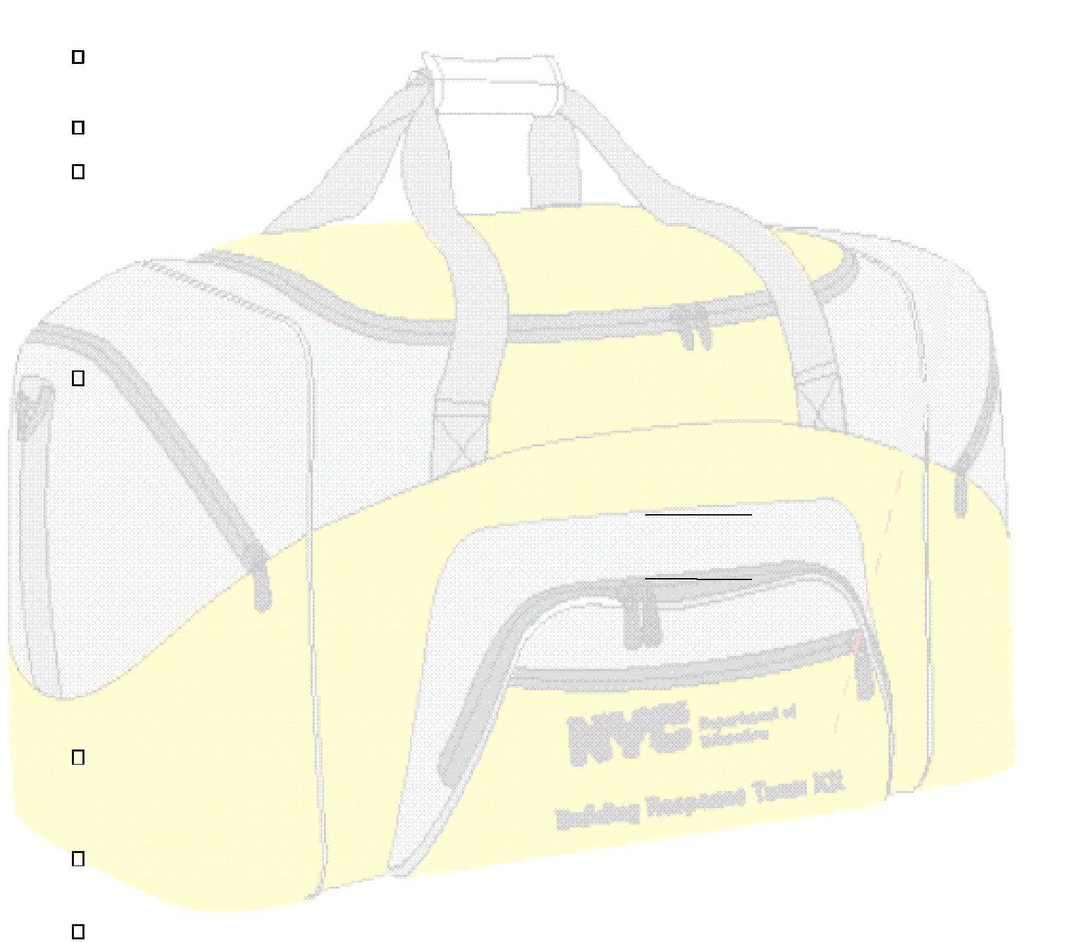
Download BRT and GRP training materials that are posted on the Principals’ Portal (see link at bottom of page).

Review all current members of the BRT to identify any vacancies or changes of BRT roles. Have the custodian survey the building to ensure:

o Door locks are in proper working order;

o The public address system can be heard in every room, office, and common space; o AED units and fire extinguishers have been serviced and are operational;

o Fire drill and GRP posters are hung in each classroom, office, and common space.

Schedule required training for staff within the building by Sept. 15 each year (include School Safety Agents, custodial team, food services, and the nurse), where critical safety topics are thoroughly reviewed, including:

o BRT members and roles in an emergency;

o GRP training focusing on the procedures for Evacuation, Shelter-In, and Lockdowns; o Distributing GRP Assembly Cards to all staff 

- Distributing to all teachers, the grade appropriate curriculum. Inform all teachers of the date by which the GRP lessons are reviewed with students. Lessons must be reviewed with students before the first fire drill.

The following items can be addressed once students return to school:

Download the GRP Parent Letters to print and send home with each student before the first drill is conducted in the building (letters only need to be sent home in September).

Review the GRP with substitute teachers and the supervisor of the after-school programs when they report to the building for their first day of work.

During the first Safety Committee Meeting, schedule tentative dates for:

- (12) Emergency Drills: 8 to be conducted through December 31; Eight are evacuation and four are Soft Lockdown Drills.

o Only 2 of the 4 Soft Lockdown Drills have dates by which the drill must be held. The first

30

This plan contains confidential information and should not be posted online, reproduced, or distributed, except in cases of emergency.

Drill is to be held by October 31, and the second drill is to be held between February 1 and March 14.

Section 10 Building Response Procedures & Assignments

Building Response Team

The Building Response Team (BRT) should consist of a BRT Leader (Principal from one of the schools on campus) and at least five additional staff volunteers who form the building’s core emergency response group. This school’s Building Response Team includes:

Name | Role | Phone Number

Site Entry Information

Is there a separate entrance for staff to enter the building that does not require scanning? No

The entrance for staff is starting at

The following entrance(s) are used by the listed staff members and students at the specified times:

31

This plan contains confidential information and should not be posted online, reproduced, or distributed, except in cases of emergency.

Internal Communications

Each school must have an internal communication system, such as a public address or intercom system. All staff members should have knowledge of the established procedures and have access to the system in case of emergencies. If your site is not equipped with a P.A. or intercom system, you must create standard protocols for communication in case of an emergency. For example, a student may bring a specific, color-coded pass to the nearest office where an adult is available to respond to an emergency.

Does this site have an internal intercom system?
If yes, do all staff have access to the internal intercom system? The main office number is (718) 527-6868.

32

This plan contains confidential information and should not be posted online, reproduced, or distributed, except in cases of emergency.

Visitor Control Procedures

The Principal (or, in buildings with multiple schools, the Principals’ Council / Campus Council) has the overall responsibility and authority to regulate admission of visitors and to oversee their conduct while in the school or on school property. Each principal also has authority to grant or deny a visitor's request to enter the school. Such decisions should be reasonable and consistent with the needs of the school, its safety, and the right of the public to visit the school.

In order to establish a uniform visitor control standard, the following procedures should be implemented in all Department of Education facilities. These procedures are designed to ensure minimum standards to control visitors to school buildings. The School Board with the Church Board approval may establish additional procedures beyond those outlined below.

- The main entrance must be covered by a Safety Agent or other appropriate staff person from the time the Custodian opens the building until the end of the school day. The Principal will assign a School Safety Agent (S.S.A.) to the main entrance. When a school's designated S.S.A. is not at that location, the Principal(s) shall designate an appropriate alternate person to be stationed at the main entrance. This person will follow the same visitor control procedures that the S.S.A. must perform.

- Signs should be posted at the main entrance informing visitors that they must stop at the desk to sign in and show photo identification. A visitor entering the building will be required to provide at least one (1) item of valid photo identification (for example, this may include a driver’s license, foreign or US passport, or consulate identification card). Parents who do not have acceptable photo identification shall not be denied access to their children’s school. Where acceptable photo identification cannot otherwise be made and there is no other reason to deny access, the principal/designee, who may be the parent coordinator, must be contacted. The principal/designee will then escort the parent to the office he or she is visiting and following the meeting escort the parent out of the building. The S.S.A. or staff member on duty at the main entrance will record the date, time, visitor’s name and visitor’s destination in the Log Book. All visitors are required to sign next to the entry made by the S.S.A. or staff person on duty. Log books must be maintained at the site for a period of three years. Posted signs should inform visitors that failing to follow these guidelines may result in their removal from the building. Please note: signs regarding visitor access must be posted in all covered languages.

- Schools must ensure that parents in need of language assistance services are not prevented from reaching the school’s administrative offices due to language barriers. If a parent or visitor does not speak English, the S.S.A. or staff member should try to determine the language the individual is speaking, and then attempt to locate a translator within the building by contacting the main office. If a translator is not present within the building, the S.S.A. or staff member on duty should escort the individual to the main office for further assitance.

- Every visitor should be given a pass to the general office. At the general office, visitors will be issued a second pass and/or appropriate instructions, should they be visiting other areas in the building. Before issuing a second pass, general office staff must confirm with the appropriate destination staff member that the visitor is expected.

- The S.S.A. or staff person at the main entrance will record the time of departure in the Visitor's Log, parallel to the initial entry for that visitor, and collect all passes issued.

- The S.S.A. or designated staff person should make a periodic check of the Log Book to ensure that no one remains in the building for an extended, unauthorized period of time. In such instance, it should be verified whether the visitor(s) is/are still in the building. In the event that a visitor remains in the building:

- Any school, program, or academy at the site may employ additional procedures (above and beyond but not inconsistent with the procedures defined above) to log visitors into the building. For example, visitors may be issued color-coded passes to specify locations in the building, or visitors may be escorted by staff or students to their destination. Special visitor log procedures:

- Visitors who violate procedures regarding visits to schools, or whose conduct jeopardizes the safety of students/staff, interferes with programs in the school, or damages property are subject to immediate removal from the school by order of the Principal, and may be subject to arrest.

- All staff members must be aware of visitors who do not have appropriate passes for a designated area, or who have no visitor's pass at all. Where feasible, staff should approach such persons and request that they return to the Main Office. Staff should then immediately notify the Principal and the S.S.A. of the situation.

33

This plan contains confidential information and should not be posted online, reproduced, or distributed, except in cases of emergency.

 | Date: __________________________ | Time Out
 | Date: __________________________ | Signature
 | School: __________________________________________________________________
 |  | Destination
 |  | Address
Visitor Log |  | Name
Visitor Log |  | Time In

34

This plan contains confidential information and should not be posted online, reproduced, or distributed, except in cases of emergency.

Emergency Situations and Procedures

The key to handling a crisis, disaster or emergency at the school level is to have plans and protocols in place that are regularly practiced by administrators, staff and students.

This section outlines protocols intended to guide administrators and staff in maintaining calm and order during an emergency. The identified examples reflect the types of events that can or may occur in schools. This list is not intended to be exhaustive.

Many of the steps recommended for specific types of crises/emergencies are transferable and can be used during other types of emergencies to quickly bring calm to school staff and students prior to the arrival of first responders. Based on the particular situation, you may be asked to evacuate your school and bring your students and staff to a location a distance away. In the case of a threat to the environment outside of the school (e.g., a building collapse, water main break or a gas leak/explosion), you may be asked to keep your students and staff in the building to avoid external dangers. To assist in the event of an emergency, Floor Plans should be readily available in Principal's Office, Library, Custodian’s Office, Security Office and Neighboring School(s).

In every disaster situation, you should take steps to immediately assess the situation, activate your building response team (BRT) and contact the New York City Police Department (NYPD) and/or the New York City Fire Department (FDNY) as soon as possible. In addition, you must have systems in place to notify parents of school emergencies. Using any school specific parent notification systems once the message is approved by your principal/superintendent for distribution to parents.

911 Protocols

Can 911 be dialed from any phone in the building(s) included on this plan? Dialing prefix: 9

35

This plan contains confidential information and should not be posted online, reproduced, or distributed, except in cases of emergency.

Medical Emergencies

IMMEDIATE ACTIONS

- Check for DANGER to yourself or others.

- Does the patient look unconscious? Is s/he convulsing, bleeding severely, or not breathing?

Gloves are available in the School’s Administration Office and/or at designated locations.

- Do NOT attempt to move a person who has fallen and appears to be in pain.

- When appropriate, trained CPR responders should perform CPR and/or First Aid until emergency responders arrive to the scene.

- If the person is having a seizure, protect her/him from injury by removing harmful objects that are nearby; cushion her/his head; and do not restrain the person.

- In case of spilled bodily fluids, put on latex gloves; cord off the area, if possible; and call the custodian, who is trained in handling blood-borne pathogens, to clean up the area.

CALL 911 with the following information:

Your NAME and TELEPHONE NUMBER;

ADDRESS of the school/facility;

NUMBER of patients and their CONDITION;

ENTRANCE for first responders to use; and,

NAME of the person(s) involved, if possible.

- A BRT member should provide first responders with incident- specific information.

- GET patient(s) NAME(s) and HOME CONTACT details, if possible and pass this information on to the BRT Leader or Recorder. REMAIN with the patient(s) until medical help arrives.

ENSURE that a staff member ACCOMPANIES the patient to the HOSPITAL if an ambulance is required. OBTAIN names of EMTs and hospital destination.

- NOTIFY Principal or the BRT Leader, Nurse, and SSA or Supervisor. Provide:

The LOCATION;

DESCRIPTION of the situation;

NUMBER of patients involved;

CONDITION of patient(s) (e.g., consciousness, breathing, pulse, injuries);

NAME(s) of affected person(s) (if known);

INFORMATION provided to 911.

- VERIFY that Principal or BRT Leader has notified all relevant persons/agencies.

- OBTAIN written statements from all witnesses and deliver to Principal.

DEATH

- For all instances of illness, injury or death, call 911.

- In cases of obvious death as evidenced by decomposition or injury incompatible with life (such as decapitation), do not approach the individual/body.

- Notify Principal and SSA or Supervisor.

- Wait for Principal to arrive and cord off the area by keeping all students and staff AWAY.

- Do NOT disturb the scene.

- Principal or BRT Leader will await arrival of emergency responders and assist as directed.

36

This plan contains confidential information and should not be posted online, reproduced, or distributed, except in cases of emergency.



General Response Protocols

The General Response Protocol (GRP) outlines the initial response to a variety of conditions that may occur inside or outside of a school building that would require the administration to either Evacuate, Shelter-In, or Lockdown the campus. Each protocol has specific staff and student actions that are unique to each response. In the event that a student or staff member identifies the initial threat, calling 911 and administration is required.

Implementation of each GRP Action is performed by all staff, students, and visitors until first responders arrive to provide specific direction to school officials.
- Evacuate is always initiated by the Fire Alarm or specific directions, and is used to move students and staff from one location to a different location out of the building. This may be used when the hazard is found inside or outside of the building. An evacuation may be conducted by the entire building at the same time, or in a controlled fashion based on the direction of first responders.

- Shelter-In is always initiated with the announcement:”Attention: This is a Shelter- In. Secure the exit doors.” and is the protocol used to safe guard students and staff within the building. It is always followed by a specific instruction and is used when the hazard is found outside of the building. The hazard may be environmental or be related to the actions of first responders in the neighborhood. Shelter-In may also include relocation to different rooms within the building.

- Lockdown is initiated with the announcement, “Attention. We are now in Soft/Hard Lockdown. Take proper action.” and is the protocol used to secure individual rooms and keep students quiet and in place. Lockdown is used when the hazard is found within the building.

Soft lockdown implies that there is no identified imminent danger to the sweep teams. Administrative teams, Building Response Teams, and School Safety Agents will mobilize at the designated command post.

Hard lockdown implies that imminent danger is known and NO ONE will engage in any building sweep activity. All individuals, including School Safety Agents will take appropriate lockdown action and await the arrival of first responders.

Shelter-In vs. Lockdown

The differentiation between Shelter-In and Lockdown is a critical element in GRP. A Shelter-In recovers all students from outside the building, secures the building perimeter and locks all outside doors. This would be implemented when there is a threat or hazard outside of the building. Criminal activity, dangerous events in the community, or even a vicious dog on the playground would be examples of a Shelter-In response. While the Shelter-In response encourages greater staff situational awareness, it allows for educational practices to continue with little classroom interruption or distraction.

Lockdown is a classroom-based protocol that requires locking the classroom door, turning off the lights and placing students out of sight of any corridor windows. Student action during Lockdown is to remain quiet.

37

This plan contains confidential information and should not be posted online, reproduced, or distributed, except in cases of emergency.

GRP Summary of Staff and Student Response

Lockdown (Soft/Hard) –Soft lockdown implies that there is no identified imminent danger to the sweep teams. Administrative teams, Building Response Teams, and School Safety Agents will mobilize at the designated command post for further direction. Hard lockdown implies that imminent danger is known and NO ONE will engage in any building sweep activity. All individuals, including School Safety Agents will take appropriate lockdown action and await the arrival of first responders

“Attention: We are now in soft/ hard lockdown. Take proper action” (Repeated twice over the PA system)

Students are trained to:

1. Move out of sight and maintain silence Teachers are trained to:

- Check the hallway outside of their classrooms for students, lock classroom doors, and turn the lights off

- Move away from sight and maintain silence

- Wait for First Responders to open door or the “All Clear” message

“The Lockdown has been lifted” followed by specific directions.

4. Take attendance and account for missing students by contacting main office

Evacuate – The fire alarm system is the initial alert for staff and students to initiate an evacuation. However, there may be times when the PA system and specific directions will serve as the alert initiating an evacuation. Announcements will begin with “Attention” and be followed with specific directions. (Repeated twice over the PA system).

Students are trained to:

1. Leave belongings behind and form a single file line. In cold weather, students should be reminded to take their coats when leaving the classroom. Students in physical education attire WILL NOT return to the locker room. Students without proper outdoor attire will be secured in a warm location as immediately as possible.

Teachers are trained to:

- Grab evacuation folder (with attendance sheet and Assembly cards).

- Lead students to evacuation location as identified on Fire Drill Posters. ALWAYS LISTEN FOR ADDITIONAL DIRECTIONS

- Take attendance and account for students.

- Report injuries, problems, or missing students to school staff and first responders using Assembly Card method.

Shelter-In – “Attention. This is a shelter-in. Secure the exit doors.” (Repeated twice over the PA system).

Students are trained to:

- Remain inside of building

- Conduct business as usual

- Respond to specific staff directions Teachers are trained to:
- Increase situational awareness

- Conduct business as usual

3. The Shelter- In directive will remain in effect until hearing the “All Clear” message “The Shelter- In has been lifted” followed by specific directions.

BRT members, floor wardens, and Shelter- In staff will secure all exits and report to specific post assignments

38

This plan contains confidential information and should not be posted online, reproduced, or distributed, except in cases of emergency.



Shooting (OUTSIDE OF THE SCHOOL)

Please note: Schools may decide to, or be directed to Shelter-In or conduct an Evacuation. They must be prepared for both scenarios.

NOTIFY Principal/designee, Borough Safety Director and the NYPD School Safety Agent or Supervisor.

Follow the GRP protocol for Shelter‐In , as outlined in previous section.

CONTACT:

- 911 – Be prepared to provide:

Your NAME and TELEPHONE NUMBER ADDRESS of the school/facility
DESCRIPTION of the situation (including number of people involved) and location DESCRIPTION of the shooter / hostage taker

TYPE of weapon, if any

ENTRANCE for first responders to use, if possible

- Emergency Information Center , 718-935-3210

- BRT Leader (who should activate the BRT)

Decision to Shelter-In should be made by Principals/BRT Leader in consultation with NYPD SSD.

Note: in some cases the Shelter‐In may require the assigned BRT members to report to their assigned exit doors. The Incident Assessor should report to all posts and ensure that BRT members have the required equipment.

Floor Wardens should be deployed to each floor to assist in the Shelter‐In , and assist in assessing conditions throughout the building to determine in an internal relocation of some classes is required.

If determined in conjunction with first responders, Evacuate  the premises following routes outlined in Section 7,

Emergency Assignments, Egresses, and Relocation Sites.

If the building cannot be re-entered, evacuated students and staff with attendance information are to be sent to the Evacuation Location as identified in Section 7, Emergency Assignments, Egresses, and Relocation Sites.

Parents must be notified for those children who need to be picked up.

The BRT Leader should work with first responders to identify the location, number and extent of injured persons. If the victim is part of the school community (staff or student), retrieve the victims’ information with home contact numbers and make notifications as necessary.

SSA / Principal will provide respective Supervisors and arriving agencies with vital information.

For those children who are picked up from school, the parents/guardians need to be advised of the situation and staff should remain at the evacuated school to direct the parents/guardians to the Evacuation Location for pickup.

39
This plan contains confidential information and should not be posted online, reproduced, or distributed, except in cases of emergency.

IF YOU WITNESS A SHOOTING OR HOSTAGE SITUATION:

• ASSESS the situation (STOP * LOOK * LISTEN)

How many people are involved? Is there a weapon?

- DO NOT PLACE YOURSELF IN DANGER.

- CALL 911 and provide information listed above.

- NOTIFY Principal or BRT Leader and SSA or Supervisor

- The Principal or BRT Leader should direct first responders to a BRT member for incident-specific information.

- Where appropriate, keep the individual IN SIGHT, but DO NOT place yourself in danger.
- Take NOTICE of clothing, speech, height, accent, behavior, and other distinguishing features.

- Remain CALM and observant.

- Discreetly instruct spectators to MOVE AWAY from scene.

- Do NOT attempt to negotiate with the individual.

- Keep a LOW PROFILE; DO NOT stand out.

- AWAIT the arrival of NYPD first responders.

- Follow instructions from first responders.

- After situation has been resolved, CONFIRM that Principal/designee has notified the Conference.

- OBTAIN written statements from all witnesses and deliver to Principal only if approval has been given by NYPD Incident Commander.

40

This plan contains confidential information and should not be posted online, reproduced, or distributed, except in cases of emergency.



Bomb Threat

Please note: Schools may decide to, or be directed to Evacuate or conduct a Soft Lockdown. They must be prepared for both scenarios.

IF YOU OBSERVE A SUSPICIOUS PACKAGE, DO NOT TOUCH IT.

ALL BOMB THREATS

- All communications by LAND LINE or IN PERSON ONLY (No radio or cell phone transmissions).

- CALL 911.

- Provide the following information: Your NAME and TELEPHONE NUMBER, ADDRESS of the school/facility, DESCRIPTION of the threat, and LOCATION of bomb inside the building (if known).

- Follow instructions provided by 911 operator.

- TURN off all RADIOS, WIRELESS DEVICES, CELL PHONES, BLACKBERRIES, etc. Such devices MAY cause a bomb to detonate.

BOMB THREAT BY PHONE

- CHECK caller ID to see if there is a number and note down.

- KEEP the caller ON THE LINE as long as possible (Do not hang up on the caller).

- LISTEN CAREFULLY, be polite and SHOW INTEREST.

- Try to KEEP the caller talking so that you can gather more information.

- ASK the following questions:

□ WHEN is the bomb going to explode? □ What KIND of bomb is it?

□ WHERE is the bomb right now? □ WHERE are you CALLING FROM?

□ WHAT does the bomb LOOK like? □ WHY did you place the bomb?

- STAY ATTENTIVE to the following:

  - BACKGROUND sounds and other identifying information on caller’s location

  - Voice Characteristics & Speech Patterns

- Try to WRITE DOWN or record the conversation. (Use BOMB THREAT CHECKLIST on next page.)

- Write down the exact TIME the call was received and the LENGTH of the call.

- Dial *69 (return call) or *57 (caller ID).

BOMB THREAT BY LETTER, E-MAIL, VOICEMAIL, FAX, GRAFFITI

- PRESERVE threat evidence; do NOT delete or erase.

- Do NOT handle the item and isolate if possible.

- MAINTAIN crime scene. Do not clean anything around the area.

NOTIFY

- IN PERSON or on a LAND LINE ONLY, notify Principal or BRT Leader and SSA or Supervisor (No radio or cell phone transmissions). ALERT them to the situation and the phone call that was made to 911, and PROVIDE a description of the threat.

- If evacuation is necessary follow GRP Protocols for evacuation  and the procedures as shown in Section 7, Emergency Assignments, Egresses, and Relocation Sites, and assist as necessary.

- In cases where a reported/suspected explosive device is found, the ranking NYPD member at the scene is in command. S/he will consult with ranking Fire Officer and other City Officials, if present, to determine if further evacuation is required or if emergency action taken should be expanded or curtailed.

41

This plan contains confidential information and should not be posted online, reproduced, or distributed, except in cases of emergency.

- If evacuation is not necessary, initiate the procedures for a Soft Lockdown  and assist first responders with a search of the building, if requested. No one is to re-enter the building/affected area without authorization from appropriate agency.

- If building cannot be re-entered, those children who are picked up from school, their parents/guardians need to be called and advised of the situation; staff should remain at the evacuated school to direct the parents/guardians to the Evacuation Location for pickup.

FOLLOW UP

- VERIFY that the Principal notified the Conference.

- OBTAIN written statements from all witnesses and deliver to Principal only if approval is given by NYPD Incident Commander.

- ENSURE that the Bomb Threat Checklist from SSP is filled out.

42

This plan contains confidential information and should not be posted online, reproduced, or distributed, except in cases of emergency.

Bomb Threat Checklist

(Photocopy this page, and keep copies near all school phones / switchboards. After completing this document, keep a copy on file and fax a copy to the Operations Center of the School Safety Division at (718) 730-8691.)

School: ___________________________________________ | Caller’s Name: _____________________________________
Date: _____________________________________________ | Time of Call: _______________________________________
Time of Report: ____________________________________ | Length of Call: _____________________________________
School Official (reporting): __________________________ | Specific wording of message:
Location of Bomb (be specific): ______________________ | ___________________________________________________
How was bomb threat received? ______________________ | ___________________________________________________

Description of Caller (Circle all that apply):

VOICE | SPEECH | MANNER/DEMEANOR | APPARENT IDENTITY | BACKGROUND NOISE
CHARACTERISTICS | CHARACTERISTICS | OF CALLER | OF CALLER
LOUD | FAST | CALM | ADULT | QUIET
SOFT | SLOW | ANGRY | TEEN | LOUD
HIGH | INTOXICATED | DELIBERATE | VERY YOUNG | MACHINE
DEEP | STUTTER | EMOTIONAL | MALE | TRAFFIC
PLEASANT | ACCENT |  | FEMALE | MUSIC

Other characteristics: ________________________________________________________________________________________

___________________________________________________________________________________________________________
___________________________________________________________________________________________________________
___________________________________________________________________________________________________________

NOTIFICATION (in order) | NAME OF PERSON NOTIFIED | TIME NOTIFIED

Principal / BRT Leader

Police Department

Safety Administrator

School Safety Division

Superintendent / Field Support Center

Other (Who?)

43

This plan contains confidential information and should not be posted online, reproduced, or distributed, except in cases of emergency.

Was the building evacuated? | YES | NO | If yes, to where? __________________________________________________
Was a search conducted? | YES | NO | If yes, time & status/result of search: ___________________________________
Did the bomb squad respond? | YES | NO

Students (circle one) WERE DISMISSED / RETURNED TO THE BUILDING AFTER INSPECTION AT (time) __________________. Is the building in stable condition? YES NO

44

This plan contains confidential information and should not be posted online, reproduced, or distributed, except in cases of emergency.



Building Collapse / Explosion

Please note: Schools may decide to, or be directed to Evacuate or conduct a Shelter-in. They must be prepared for both scenarios.

CONTACT

- 911

- SSA or Supervisor

- Principal (notifies the conference)

- Pastor Emergency Information.

- BRT Leader (activates the Building Response Team)

- Custodial Engineer

IMMEDIATE ACTIONS

- Check for DANGER to yourself or others.

- BE PREPARED for possible further explosion/collapse.

- Remember to STOP * LOOK * LISTEN.

- Assess safety of evacuation routes and EVACUATE  the building when safe to do so, following the GRP Protocol for Evacuation, and as identified in Section 7, Emergency Assignments, Egresses, and Relocation Sites. If Evacuation routes are unsafe, be PREPARED to initiate the GRP SHELTER-IN  procedures until first responders arrive

- Check for INJURED PERSONS, but DO NOT ENDANGER YOURSELF.

- Identify and maintain contact with injured parties until emergency responders arrive.

CALL 911

• Let the operator ask you questions and be prepared to provide the following information: Your NAME and TELEPHONE NUMBER

ADDRESS of the school/facility DESCRIPTION of the situation

NUMBER of injured persons, location and extent of injuries (if known) ENTRANCE for first responders to use.

• The Principal or BRT Leader should direct, as appropriate, first responders to a BRT member for incident-specific information.

NOTIFY

- NOTIFY Principal or BRT Leader and SSA or Supervisor of the LOCATION of the incident, DESCRIPTION of the situation, Number of INJURED PEOPLE.

RESPOND

• ASSIST the Custodial Engineer as directed.

FOLLOW UP

- Principal to notify Pastor.

- CONFIRM that the Principal has notified the conference.

- Prepare for EARLY DISMISSAL or TRANSPORTATION OF STUDENTS, if necessary.

45

This plan contains confidential information and should not be posted online, reproduced, or distributed, except in cases of emergency.



Chemical Spill or Natural /

Propane Gas Leaks

Please note: Schools may decide to, or be directed to Evacuate or Shelter-In. They must be prepared for both scenarios.

CONTACT

- 911

- SSA or Supervisor

- Principal (notifies the Conference)

- Pastor notification.

- BRT Leader (activates the Building Response Team)

- Custodial Engineer

IMMEDIATE ACTIONS

- Check for DANGER to yourself or others.

- ALERT Custodial Engineer and INFORM him/her of the location of leak/spill and the substance (if known).

- Do NOT approach or attempt to contain the leak/spill.

- EVACUATE and CORDON OFF the immediate area.

- For internal relocation of classes affected by the spill/leak, keep track of student and staff relocation.

- If persons have inhaled gas, get them to FRESH AIR.

- If there are injured persons, CALL 911 with the following information:

Your NAME and TELEPHONE NUMBER

ADDRESS of the school/facility

NUMBER of patients and their CONDITION

ENTRANCE for first responders to use

NAME of the person(s) involved, if possible

NOTIFY

- NOTIFY Principal or BRT Leader, SSA or Supervisor of the situation.

- REMIND Principal to notify the Conference.

- CUSTODIAL ENGINEER to notify Director / Deputy Director of Facilities.

RESPOND

- If requested, ASSIST Custodial Engineer to determine the source of the leak/spill.

- Prepare for building-wide evacuation . If evacuation is necessary (as determined by principals in consultation with external incident commander), follow GRP for Evacuation, and procedures as defined in Section 7, Emergency Assignments, Egresses, and Relocation Sites.

FOLLOW UP

- After the situation has been resolved, the external incident commander or liaison will advise the Principal and/or BRT Leader when the situation is ALL-CLEAR.

46
This plan contains confidential information and should not be posted online, reproduced, or distributed, except in cases of emergency.

Fire/Evacuation Emergency

CONTACT

- 911

- Principal (notifies the conference)

- Pastor contacted

- BRT Leader (activates the Building Response Team)

- Custodial Engineer

PULL FIRE ALARM

ASSESS

• Stay AWARE and ALERT.

NOTIFY

• NOTIFY Principal or BRT Leader, and Custodial Engineer of the LOCATION and EXTENT of the emergency situation.

ACTIONS TO TAKE

- ASSESS safety of egress routes.

- If primary egress contains smoke, do not use.

- Feel door with back of hand and if hot, do NOT open.

• Follow GRP for Evacuation and the procedures as defined in Section 7, Emergency Assignments, Egresses, and Relocation Sites. An alarm must be sounded and all students and staff must be evacuated when an emergency arises or is suspected. The decision must be made immediately; investigation of the emergency should be made after everyone has safely left the building.

- Close fire doors and other doors to contain fire.

- Direct people to evacuate away from fire and smoke.

- The Principal or BRT Leader should assign a BRT member to join a custodial staff member to direct first responders to the scene.

- The Custodial Engineer should:

In oil-fired plants, shut down all oil burner equipment using switches on oil burner control board or remote control switch. Close suction line valves closest to oil tanks. Leave dampers open. Shut down air compressors and bleed lines to thermostats, maintain water level in boilers.

Pull switches for power to school instructional equipment, blowers, ventilators, etc. Switches for the lights should be left on. Boiler room switches should be left on.

- Prepare for EARLY DISMISSAL or TRANSPORTATION OF STUDENTS, if necessary. The decision to evacuate will be made only by Principal/BRT Leader in consultation with NYPD SSD. No one is to re-enter the building without authorization from appropriate agency.

- If the building cannot be re-entered, evacuated students and staff with attendance information are to be sent to the Evacuation Location as identified in Section 7, Emergency Assignments, Egresses, and Relocation Sites. In addition, the Office of Pupil Transportation must be notified for those children who take the bus home. For those children who are picked up from school, the parents/guardians need to be called and advised of the situation and staff should remain at the evacuated school to direct the parents/guardians to the Evacuation Location for pickup.

FOLLOW-UP

- Custodial Engineer to update Director/Deputy Director of Facilities.

- CONFIRM that the Principal has updated the Emergency Information Center.

- When fire is extinguished, recharge all used fire extinguishers immediately.

47

This plan contains confidential information and should not be posted online, reproduced, or distributed, except in cases of emergency.

Fire Safety & Fire/Evacuation Drills

All school staff should receive an annual orientation session concerning fire safety at the beginning of each year. By the end of this session, participants should:

- Know appropriate methods of transmitting an alarm, including telephones, fire alarm boxes in the school building, and street fire alarm boxes. (Pull-lever stations for the interior alarms are at various locations in the school building, generally near stairs or exits; these interior alarms do not transmit a signal to the Fire Department.);

- Know the location and proper use of fire alarm signal boxes, fire extinguishers, and other fire-fighting apparatus;

- Understand regulations regarding flammable materials, stage settings, decorations, electrical equipment, chemical substances in laboratories, and other potential fire hazards; and,

- Know fire exit drills and evacuation plans.

The Custodial Engineer should conduct an inspection of all school/campus buildings daily, with particular attention to potential fire hazards, proper equipment, access to fire doors, and visibility of signs.

Building occupants must be able to open all exit doors from the inside at all times. Chaining or padlocking fire doors is a punishable violation of the Administrative and Fire Safety Codes.

Signs prohibiting use of elevators during fire drills and emergencies, including information regarding appropriate stairway exits, must be posted near elevators.

Fire/Evacuation Drills

Frequent unannounced drills, implemented with proper leadership and discipline, help ensure safe evacuation in an actual emergency. Drills should be planned in advance, and fire safety/evacuation information should be posted conspicuously throughout the building.

- Purpose

  - The purpose of fire/evacuation drills is to instruct and train students and staff in emergency evacuation procedures so that they might leave the school building in the shortest time possible and without panic in the event of an actual emergency. On hearing the fire signal (three gongs, four times), pupils (under the leadership of teachers and other school staff) must go to the street without delay.

- Frequency and Monitoring

  - AS REQUIRED BY STATE LAW, THE PRINCIPAL SHALL HOLD EMERGENCY DRILLS NO LESS THAN TWELVE TIMES IN EACH SCHOOL YEAR, EIGHT OF WHICH SHALL BE HELD PRIOR TO DECEMBER 31. OF THE REQUIRED TWELVE EMERGENCY DRILLS THAT MUST BE CONDUCTED, FOUR DRILLS MUST BE LOCKDOWN DRILLS AND THE REMAIING EIGHT MUST BE EVACUATION DRILLS. Neglect by a Principal, or other person in charge, to comply with the above requirements is a misdemeanor punishable by a fine and/or imprisonment.

  - In buildings with fire escapes, at least four of the drills shall include the use of such escapes.

  - In buildings in which summer school is conducted, at least two additional fire/evacuation drills shall be conducted, one of which shall be held the first week of summer school.

  - A record and evaluation of each fire/evacuation drill shall be maintained. All drill reports completed by Principals are to be filed in a safe place.

- Guidelines

  - All students and staff in the school must obey fire drill signals and regulations.

  - Equal emphasis should be placed on evacuating the school in a quick and orderly fashion. No running or horseplay shall be tolerated.

  - Fire/Evacuation drills shall be conducted under varying circumstances at varying hours and at unannounced times to simulate actual emergency conditions. (For example, one exit should be blocked by closing off the exit area during the fire drill.)

  - Ringing the fire bell is the usual signal for a drill. However, staff and students should be aware of alternate procedures in case of malfunctioning of the bell system. Alternate signals, such as classroom bells, public address announcements, hand bells or messengers, may be used.

  - Instructions involving fire/evacuation drills and evacuation paths to be used shall be posted in every classroom, auditorium, and cafeteria. (Note: Fire/Evacuation Drill Posters may be ordered in packages of twenty-five from the Division of Contracts and Purchasing online catalog four times per year -- choose item #11-25-2590-007 on the FAMIS portal.)

  - Details of the school's fire/evacuation drill plan should include the current number of students in holding rooms. Holding rooms are designated areas where physically handicapped students and staff wait for the Fire Department. The Fire Department will

48

This plan contains confidential information and should not be posted online, reproduced, or distributed, except in cases of emergency.

provide means of egress, when necessary. The fire drill is not complete until all students are out of the building or in holding rooms. Holding rooms must be left unlocked during occupancy.

- Teachers shall bring attendance information with them to ensure the safe evacuation of all students.

Shelter-In

Shelter-In – “Attention. This is a shelter-in. Secure the exit doors.” (Repeated twice over the PA system).

Under some circumstances, when the hazard to the school is outside of the school, emergency responders may direct that your students and staff remain within the school building. This process, called “sheltering-in,” may allow operations to function within the building as they normally do, or may require that you identify a location in your school where students and staff can congregate that is a) in a hallway and away from windows and glass; b) in an area that is isolated; c) in an area where ventilation can be turned off, if needed; and/or d) away from the main entrance of your school.

The determination that staff and students should remain inside during a disaster will be made by local law enforcement / public safety officials. Once that decision has been made, school staff may be given particular direction regarding appropriate shelter-in locations (e.g. basement areas; gymnasium; particular hallways), as well as critical actions to ensure ongoing safety from the danger outside of the school building.

CONTACT

- 911

- SSA or Supervisor

- Principal (notifies conference)

- Pastor notification.

- BRT Leader (activates the Building Response Team)

- Custodial Engineer

These steps can applied to emergency weather shelters (e.g., tornado, severe storms, hazardous materials release) and/or first responder activity outside of the school building (e.g., a police search for individuals, FDNY activity in a home on the block of the school).

- The Principal will follow the GRP protocol for Shelter-In. 

- Shelter Locations should be predetermined, but will vary depending on the nature of the incident.

- CONSULT with the Principal, BRT Leader, Custodial Engineer and other BRT members to coordinate efforts and approach.

- The BRT Leader should confirm that the Principal has notified the Custodial Engineer has notified the Director / Deputy Director of Facilities.

SHELTER-IN

- BRT response actions will depend on the nature of the incident.

- DO NOT PLACE YOURSELF IN DANGER.

- ASSIST Principal and Custodial Engineer as necessary.

• Remain alert as a Shelter- In may transition into an Evacuation or a Lockdown • If there are injured people, refer to the Medical Emergency Procedures.

- REMAIN CALM and care for medically fragile students around you.

- Follow Principal/BRT Leader’s directions and be prepared to carry out the following actions:

INSTRUCT all individuals to REMAIN INDOORS. DIRECT them to the internal relocation areas if applicable (including visitors who remain in building)

49

This plan contains confidential information and should not be posted online, reproduced, or distributed, except in cases of emergency.

Instruct teachers to CLOSE all windows and doors (if applicable for environmental hazards).

Do NOT allow any individuals to enter into the building (except for NYPD or other first responders).

Upon arrival of NYPD, follow instructions of NYPD Incident Commander.

- CONFIRM that teachers have taken attendance.

- STAY ALERT and AWAIT further instructions from the Principal, Custodial Engineer, or first responders.

Unless otherwise stated, the school community functions as normal with the exception of entry and egress until the All Clear announcement is made, “The Shelter- In has been lifted” followed by specific directions

FOLLOW-UP

- Once the building has been properly secured, verify that Custodial Engineer has updated the Director/Deputy Director of Facilities and that principal has updated the conference.

50

This plan contains confidential information and should not be posted online, reproduced, or distributed, except in cases of emergency.

Lockdown Drills

Section 2801 of New York State Education Law requires schools to develop Safety Plans regarding Emergency Response. In accordance with this, schools need to conduct drills and other exercises to test components of the Emergency Response Plan. All Public schools are required to conduct 4 Soft Lockdown drills per year. One drill must be conducted in the Fall Term (by October 31) and one drill conducted during the Spring Term (between February 1 and March 14). The remaining two drills may be conducted at anytime during the school day as determined by the administrative team. Drills must be recorded in the DOE online Lockdown Drills data entry page within 48 hours of commencement of the Drill.

Lockdown

Lockdown is to be used when there is a threat or hazard inside of the building.

Lockdown (Soft/Hard) –Soft lockdown implies that there is no identified imminent danger to the sweep teams. Administrative teams, Building Response Teams, and School Safety Agents will mobilize at the designated command post for further direction. Hard lockdown implies that imminent danger is known and NO ONE will engage in any building sweep activity. All individuals, including School Safety Agents will take appropriate lockdown action and await the arrival of first responders

“Attention: We are now in soft/ hard lockdown. Take proper action”

(Repeated twice over the PA system)

In response to this announcement:

Students are trained to:

1. Move out of sight and maintain silence

Teachers are trained to:

- Check the hallway outside of their classrooms for students, lock classroom doors, and turn the lights off

- Move away from sight and maintain silence

- Wait for First Responders to open door or the “All Clear” message

“The Lockdown has been lifted” followed by specific directions.

- Take attendance and account for missing students by contacting main office

  - any students in the hallway should immediately be taken to nearest classroom by school personnel;

  - the Principal or designated BRT member should call 911 and provide: name and telephone number, address of the building, description of the situation and any weapons involved, entrance for first responders to use; and,

  - the Principal or designated BRT member should contact the conference.

51

This plan contains confidential information and should not be posted online, reproduced, or distributed, except in cases of emergency.


Linden SDA School

This checklist is designed to be used during a soft lockdown drill.
Follow these steps sequentially to ensure that all soft lockdown elements are completed.

BEFORE A DRILL

- All members of the school community were notified of the drill, including: school safety agents, food service staff, school nurse, substitute teachers, and custodial employees as they will all participate in the drill.

- The custodian, nurse and 1 school safety agent were reminded that they are command post staff (in addition to the Principal(s), BRT Leader, and the Recorder). They should remain in the command post for the duration of the drill in case an issue which requires their immediate response is reported.

- All BRT Members, floor wardens, searchers, and school safety agents were notified just prior to the

drill and were deployed to a staging area (i.e., stairwell) near their assignment to wait for the commencement of the drill.

DURING A SOFT LOCKDOWN DRILL (Record all times)

- The following announcement is made clearly and calmly 2 times:

“This is a drill. Attention, this is a soft lockdown. Take proper action.”

Time:

The following actions should occur simultaneously after calling 911 (ONLY DURING AN ACTUAL EMERGENCY; Do not call 911/ emergency responders during a drill.):

☐ The Building Response Team was activated. Time: _____________________

- The following were notified:

 |  |  | Phone Number |  | Time
DO NOT CALL | ☐ | 911 | 911
FOR A DRILL |  | Pastor
FOR A DRILL | ☐ | Pastor

  - Borough Safety Director

  - Superintendent

  - Field Support Center

- The following announcement must be made via two-way Radio and/or PA system:

“All principals and command post staff are to report to the command post in Room ______.”

52

This plan contains confidential information and should not be posted online, reproduced, or distributed, except in cases of emergency.

- Floor teams contacted the command post via phone or radio to report the condition of their designated floors. This includes whether the floors are all clear, if individuals are locked out of rooms, and why these individuals were not inside of classrooms.

- Once all reports from floor teams indicate “all clear” conditions, the following announcement is made clearly and

calmly 2 times to end the drill: “The lockdown has been lifted.” Time: ___________________

AFTER A DRILL

- Floor teams remain on post ensuring that the building has returned to normal operations.

☐A debrief session is held with all team members to identify areas of strength and areas in need of improvement

**This checklist should be duplicated and stored in the Principal’s Office, the BRT Kit, and in the primary and alternate internal Command Posts for use in a drill, as well as during an emergency.**

53

This plan contains confidential information and should not be posted online, reproduced, or distributed, except in cases of emergency.



Linden SDA School

Missing Student Protocol and

Responding to Door Alarms

In order to ensure a safe learning environment, it is important that all staff members are familiar with the Missing Student Protocol and the Response to Door Alarms Document which provide guidance on the steps that must be taken when a student is reported lost or missing, and when a door alarm is activated Both documents describe when it is appropriate to activate these protocols. In addition, the elementary school staff should be familiar with the protocol that must followed when an elementary school student is observed leaving the school building or school grounds without authorization.

Using the Missing Student Protocol

This protocol must immediately be followed when a student has been reported missing, the student’s whereabouts cannot be confirmed, and there is concern for the student’s safety or well‐being. Schools must be prepared to initiate a soft‐lockdown AND assign staff to secure the exit doors in an effort to prevent the student from leaving the building.

The Missing Student Protocol is not always an appropriate response and therefore should not be activated for every situation where a child leaves class or a school building without authorization (i.e. cutting), as the DOE has existing procedures to address these situations. Regardless of whether the protocol is activated, parents must be informed whenever a student leaves a school building without authorization.

In determining whether to activate the protocol, the following shall apply:

The protocol must be activated if the whereabouts of the following students cannot be immediately confirmed:

All students in Grades K‐5

Any student who has a known physical or emotional condition, or a cognitive disability which interferes with his or her ability to travel independently and interact with the community

In all other situations, schools must consider a number of relevant factors in determining whether the situation requires the activation of the protocol, including:
Whether the student has a prior history of leaving the building

Whether the student is dealing with a crisis/trauma or is otherwise vulnerable

Whether the student’s parent has informed the school of a prior commitment or appointment that requires the student to leave early

Whether the age and/or maturity of the student is a cause for concern regarding the student’s well‐ being

54

This plan contains confidential information and should not be posted online, reproduced, or distributed, except in cases of emergency.

THE FOLLOWING STEPS MUST BE TAKEN IF IT IS DETERMINED THAT THE MISSING STUDENT PROTOCOL SHOULD BE ACTIVATED

If it is confirmed that the student has exited the building:

Immediately call 911 (including transit police), and notify the Principal/Designee, NEC Education office, and NEC Risk Management Office. Provide a clear description of the student, to include the information below:

Height and approximate height
Ethnicity
Complexion and hair color

Attire and any distinguishing features Verbal or non‐verbal

Languages spoken

In addition, it should also be noted where the child was last observed.

Notify the School Safety Agent (SSA) in the building so that they can activate their protocols.

Immediately monitor the video surveillance system (if applicable) including perimeter cameras.

Notify the parent.

Review the Blue Card to identify any relatives listed who may live near the school. This information may be relevant in locating the missing student.

Activate the Building Response Team (BRT) and open the Command Post and gather all relevant information necessary to work with first responders and law enforcement (description of the student, blue card information, photograph (if available). If applicable, review the student’s Individual Education Plan (IEP) to determine what additional supports are required.

When the parent arrives at the school, escort the parent to the main office/Command Post so that the parent may discuss the incident with school officials and law enforcement. Where applicable, have the Pastor/parent coordinator accompany the parent in order to provide additional support to the family. A representative of the school crisis team should also report to the Command Post to provide support to the family.

55

This plan contains confidential information and should not be posted online, reproduced, or distributed, except in cases of emergency.

If it cannot be confirmed that the student has exited the building:

Notify the Principal/Designee and the School Safety Agent.

Provide a clear description of the student, including where the child was last observed. Include the information

below in the description:
Height and approximate weight Ethnicity

Complexion and hair color

Attire and any distinguishing features Verbal or non‐verbal

Languages spoken

Activate the BRT, and open the Command Post. Provide all BRT members, School Safety Agents, Shelter‐ In staff, and floor searchers, a description of the student, and if available, a photograph of the student. If applicable, review the student’s IEP to determine what additional supports are required.

Immediately monitor the video surveillance system (if applicable) including perimeter cameras.

Initiate a soft lock‐down and assign Shelter‐ In staff to secure the exit doors. Use the following language: “Attention, this is a soft lock‐down. Take proper action. All staff, we are looking for (use the name and description you have). If you know where this student is, please call extension (insert the phone extension to call).”

If the student is observed on the camera system, immediately deploy search staff to the location where the student was observed. This includes areas outside of the school building.

Inside the building, all rooms and offices, including restrooms and access to the basement must be searched.

After an initial sweep of the building, if the student has not been located, immediately call 911 (including transit police), NEC Conference Office, and the Pastor.

If available, provide law enforcement with a photograph of the missing student.

Notify the parent of the student and continue searching the building.

Review the Blue Card to identify any relatives listed who may live near the school. This information may be relevant in locating the missing student.

When the parent arrives at the school, escort the parent to the main office/Command Post so the parent may discuss the incident with school officials and law enforcement. Where applicable, have the Pastor/parent coordinator accompany the parent in order to provide additional support to the family. A representative of the school crisis team should also report to the main office/Command Post to provide support to the family.

56

This plan contains confidential information and should not be posted online, reproduced, or distributed, except in cases of emergency.

Follow‐up steps for all students:

Schools are required to use appropriate guidance and other interventions to respond to all students who leave class or a school building without authorization, regardless of whether the protocol is activated.

Schools must record and keep files and enter updates as needed of ALL incidents.

In ALL incidents where a student leaves the building without authorization, schools must review existing building protocols with the student and other students where appropriate to prevent recurrence of similar behavior.

57

This plan contains confidential information and should not be posted online, reproduced, or distributed, except in cases of emergency.

DOOR ALARM RESPONSE PLAN

All schools must create a building specific response plan that can be utilized together with the door alarm response protocol to respond when a door alarm has been activated. The guidance below is designed to support school leaders and staff members in developing their building specific response plans and when responding to an activated door alarm. A template for the Door Alarm Response Plan can be found in the School Safety Plan.

Every adult in the building has some responsibility when a door alarm is heard. All staff must receive training that outlines how the alarms operate, the required maintenance, what to do when any adult in the building hears a door alarm, and when to use other emergency response actions including the General Response Protocols and the Missing Student Protocols.

Door Alarm training and the development of a Door Alarm Response Plan for each school building must be completed before students report for their first day of the school term.

Training must also be conducted during summer school so that all staff are aware of building specific procedures on summer co‐locations.

Responses by staff are different if you are with or without students when a door alarm is activated.

Staff assigned the responsibility of responding to activated door alarms (including School Safety Agents) must have a key that is distributed by the principal.

An effective response plan is based on regular collaboration and communication between all staff, including SSAs.

SSAs will respond to incidents and work closely with school staff to address issues. Regarding door alarms, School Safety Agents will visually inspect the doors and the alarms while on routine patrol. When an alarm is activated, they will respond to the location and immediately investigate the cause so that proper action can be taken. School Safety Agents are issued keys to the alarms so that if they are the first one to respond to an alarm, they can turn it off while investigating as the alarm sound can be disruptive.

The SSA is not part of the regular door alarm test and should not be part of the building specific door alarm deactivation procedures for alarms that will be temporarily deactivated throughout the school day.

58

This plan contains confidential information and should not be posted online, reproduced, or distributed, except in cases of emergency.

DOOR ALARM RESPONSE PROTOCOL

THE FOLLOWING STEPS MUST BE TAKEN WHEN A DOOR ALARM IS ACTIVATED

All adults who are NOT supervising students must do the following when they hear an activated door alarm:

o Immediately report to the door where the alarm has been activated to observe conditions and to determine the possible cause of the alarm (i.e. staff or students observed in stairwell, student running from scene in the hallway, door propped open).

o Immediately call the appropriate office and/or main desk to report the specific location of the door alarm that was activated and share any observations.

o If the person who hears the door alarm is someone in possession of a two‐way radio (e.g. administrator, dean, security school aide) or if a School Safety Agent (SSA) is present, immediately use the radio to report the specific location of the door alarm that was activated to other staff with radios so that everyone can respond with accurate information.

For all adults who ARE supervising students when they hear an activated door alarm:

- Immediately call the appropriate office and/or main desk and report the specific location of the door alarm that was activated.

- Immediately look outside the classroom window and/or look outside the classroom door in an effort to observe anything that may provide additional information such as a staff member/
student(s) walking away from the door.

o Report observations to the staff members and/or SSAs who respond to the door alarm.

If the door alarm was activated and the cause for the alarm is believed to be the result of an intruder or a missing student, the General Response Protocols and/or Missing Student Protocols must be activated, as appropriate, based on the specific information in each incident.

PROTOCOL FOR WHEN AN ELEMENTARY STUDENT IS OBSERVED LEAVING A SCHOOL BUILDING OR SCHOOL GROUNDS WITHOUT AUTHORIZATION:

When an elementary school student leaves a school building or school grounds without authorization, it is an inherently dangerous situation and immediate steps must be taken to ensure the student’s safe return to school. The following procedures must be followed when a staff member observes an elementary school student leave the school building or school grounds without authorization.

For Staff Members Supervising Students:

- A staff member who sees an elementary student leaving the school building or school grounds without authorization and who is supervising students, must immediately inform any staff member that is nearby to follow the student unless there is a School Safety Agent (SSA) in the staff member’s immediate vicinity who can be informed of the student’s unauthorized departure. In such cases, the SSA will pursue the student. The staff member must immediately notify 911 and the principal/designee who will activate the Missing Student Protocol, when it is confirmed that the student exited the building and cannot be returned by the SSA.

59

This plan contains confidential information and should not be posted online, reproduced, or distributed, except in cases of emergency.

- If there is not an SSA or another adult in the staff member’s immediate vicinity, the staff member must immediately notify 911 by radio or cell phone, if available and provide the following information below, where possible:

Location and direction where the student was last observed
Height and approximate height
Ethnicity
Complexion and hair color

Attire and any distinguishing features Verbal or non‐ verbal

Languages spoken

In addition, the staff member must immediately notify the principal/designee and the Missing Student Protocol will be activated

60

This plan contains confidential information and should not be posted online, reproduced, or distributed, except in cases of emergency. Print Date: 9/22/2016, 1:25:09 PM

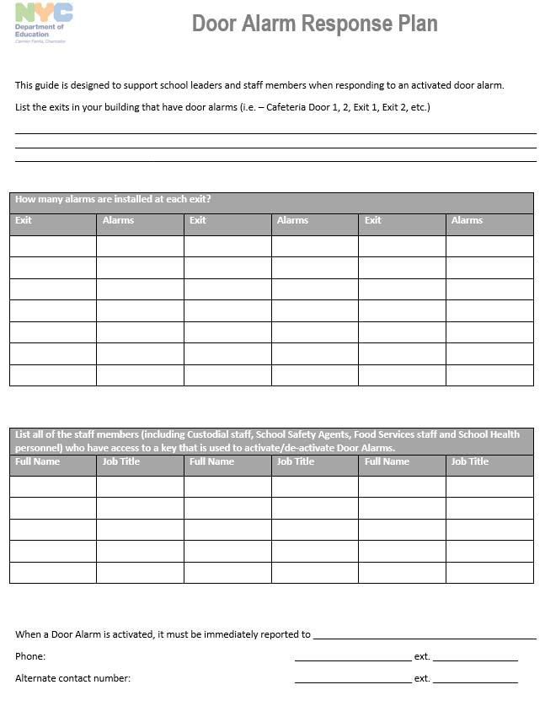

Linden SDA School

61

This plan contains confidential information and should not be posted online, reproduced, or distributed, except in cases of emergency.

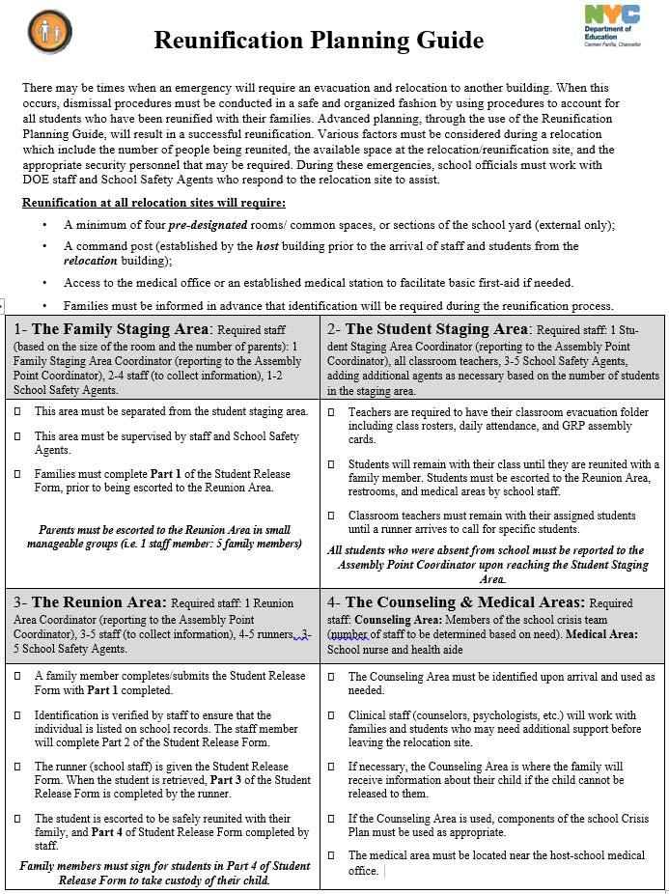

Linden SDA School

62

This plan contains confidential information and should not be posted online, reproduced, or distributed, except in cases of emergency.

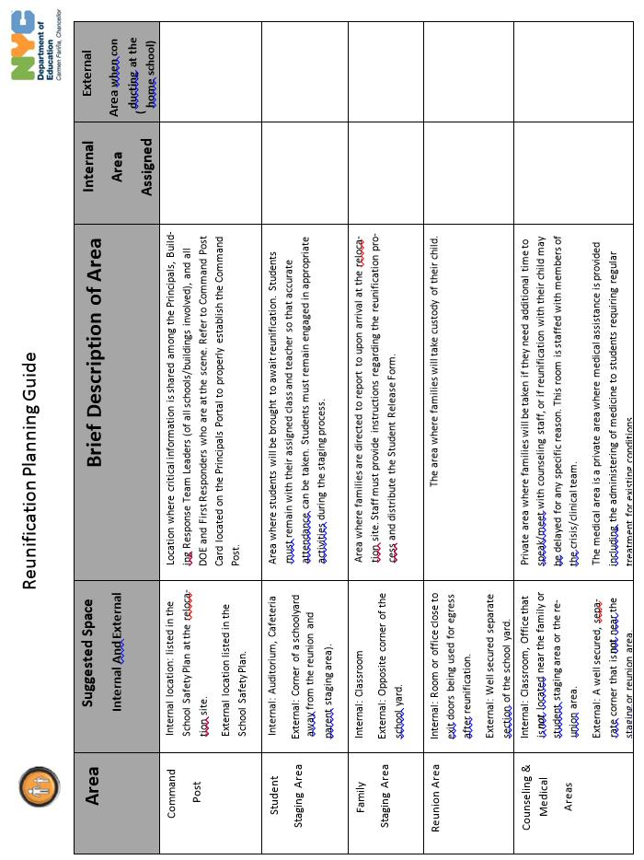

Linden SDA School

63
This plan contains confidential information and should not be posted online, reproduced, or distributed, except in cases of emergency.

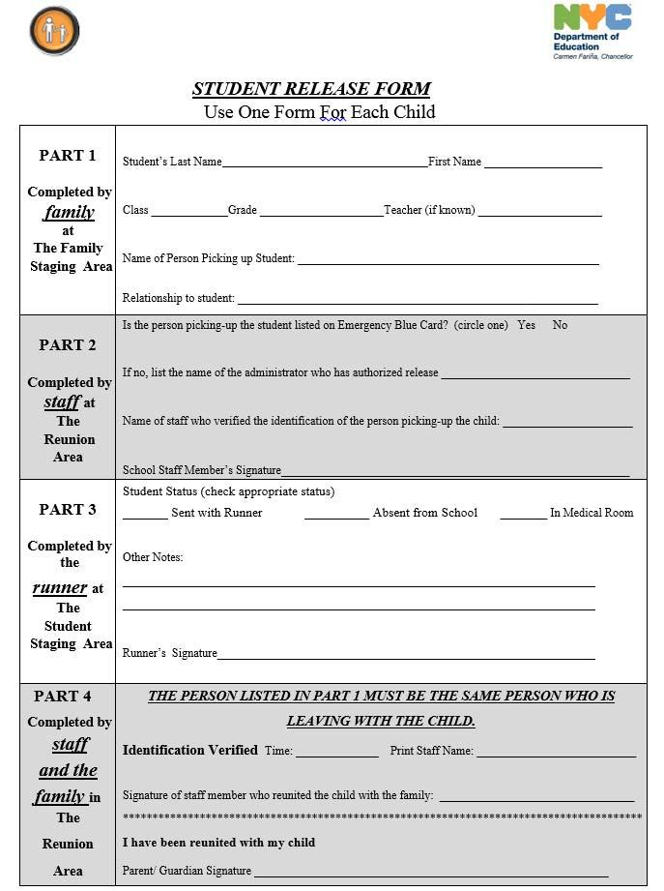

Linden SDA School

64
This plan contains confidential information and should not be posted online, reproduced, or distributed, except in cases of emergency.

Reunification Protocols

Is this building being used as a Relocation Site for another school building? |  | No
Staging Area Type | Designated Room/Area
Family Staging Area | Main Building, Room:
 | Staging Area Coordinator:
 | Staff Assigned:
Student Staging Area | Main Building, Room:
 | Staging Area Coordinator:
 | Staff Assigned:
Reunion Area | Main Building, Room:
 | Staging Area Coordinator:
 | Staff Assigned:
Counseling/Medical Area | Medical Staff Assigned:

Closing Procedures

Once the building has been properly secured, and the All Clear has been issued, the BRT, School Safety Agents, and first responders should conduct a total building sweep to ensure that conditions are safe and secure. The Principal or designee should provide updates to the Emergency Information Center. Afterwards, the Principal or designee should obtain written statements from all witnesses ONLY if approval has been given by the NYPD Incident Commander.

At the conclusion of this sweep and before the Security Team leaves, will confirm with Dr. Usher (Principal) that the

building has been secured.

65

This plan contains confidential information and should not be posted online, reproduced, or distributed, except in cases of emergency.

Section 11 Supplemental Documents

The School Safety Committee may list supplemental documents that provide pertinent information to emergency responders that will aid in a safe and efficient response. Supplemental Documents will be kept on file in the school with the hard copy of the School Safety Plan. These documents do not supersede or amend any state or Federal regulations..

Examples:

- List of Chemistry Lab Inventory

- Information on ongoing construction

- Potential environmental hazards in the immediate area of the School

No supplemental documents have been listed for the School Safety Plan.

66

This plan contains confidential information and should not be posted online, reproduced, or distributed, except in cases of emergency.

Section 12 Committee Members & Meetings

The School Safety Committee shall be comprised of the following individuals:

- First Elder of the Linden SDA Church;

- Principal/Designee of any other program operating within the building;

- Home & School Leader;

- Custodial Engineer/Facilities Director;

- In-house School Safety Agent Level supervisor/Designee;

- NYPD Precinct Commanding Officer/Designee;

- Pastor;

- Dietician/Designee of food services for the site;

- Representative of the Student Body; and

- School Board Chair.

- FDNY Liaison

The following individuals are listed as members of the School Safety Committee:

Name | Title | Program
Elder P Small | Frist Elder
 | Student representative
 | School Safety Agent
Michael Coyle | NYPD Precinct CO/Designee
Dr. L. Usher | Principal
Darwin Munroe | Home & School Leader
Warner Richards | Pastor
D. A. Lauther | School Board Chair
Mazie Richards | Cafeteria Administrator/Contractor
Juan Bacchus | Head Custodian/Facility Director
 | FDNY Liaison

NOTE: All programs/schools in operation within the building must be represented on the committee. Refusal to sign the plan on the Endorsement Page by members of the above School Safety Committee, without addressing the issue at the School Safety Committee, will not preclude the plan from being submitted and approved. If there are issues that cannot be settled at the committee level, a formal grievance may be filed and mediated.

67

This plan contains confidential information and should not be posted online, reproduced, or distributed, except in cases of emergency

Proposed Committee Meeting Dates

School Safety Committee meetings must be held monthly on days when the school is open for instruction. Attendance and agendas for each meeting must being collected online in the School Safety Committee Meetings module of the School Safety Plan Application.

The School Safety Committee will meet as a team on the dates listed below:

2017 2018

September, |  | 2016 | January | , 2017 | April | , 2017
October, 2016 |  |  | February , 2017 |  | May , 2017
November | , 2016 |  | March, | 2017 | June | , 2017
December | , 2016

68

This plan contains confidential information and should not be posted online, reproduced, or distributed, except in cases of emergency.

School Safety Plan Endorsement

Academic Year 2016-2017

This completed and signed signature page must be submitted to the NEC Education Office, the NEC Risk Management Office, the Pastor of the Linden SDA church prior to your first submission prior to October 1st.

______________________________________________________________________________________________ ______________

- School Principal Date

______________________________________________________________________________________________ ______________

-School Board Chairman Date

______________________________________________________________________________________________ ______________

- Head Custodian/Facilities Director Date

______________________________________________________________________________________________ ______________

- Home & School Leader Date

______________________________________________________________________________________________ ______________

-Pastor, Linden SDA Church Date

______________________________________________________________________________________________ ______________

- School Safety Agent Date

______________________________________________________________________________________________ ______________

- NYPD Precinct CO/Designee Date

______________________________________________________________________________________________ ______________

- FDNY Liaison Date

Original signatures are required on this page

69

This plan contains confidential information and should not be posted online, reproduced, or distributed, except in cases of emergency.

